CLOUDETHIX
Que 1 →
● Create 1 Public Docker Hub registry named flask_webapp_yourname.

flask_webapp_alam repo created

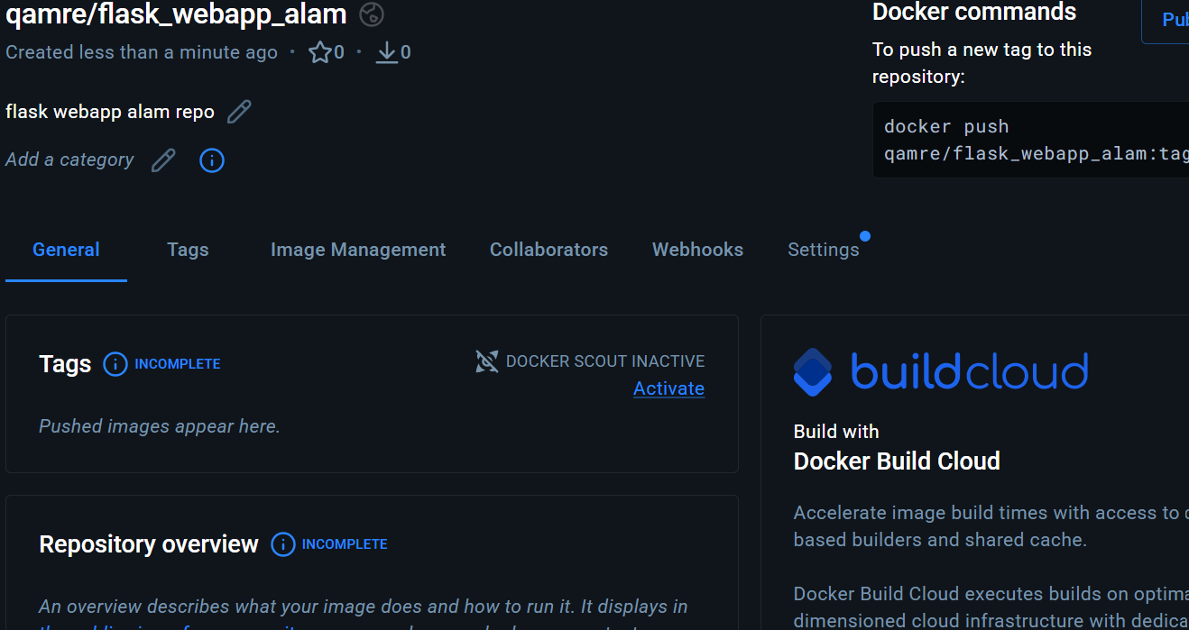

● Clone below repository on your system.
https://github.com/mmumshad/simple-webapp-docker.git

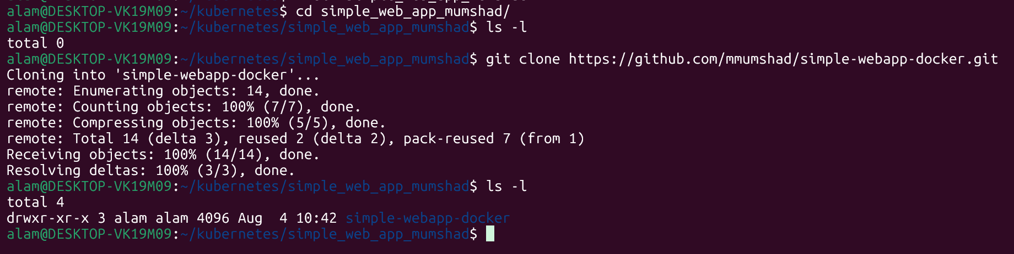

● Initialize a local repository & copy the code from above repo to your local repository in your working branch.

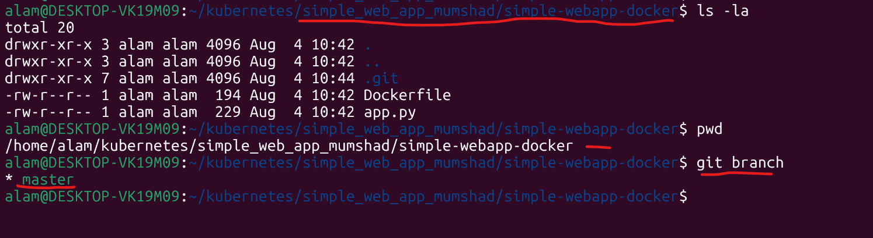

● Once code is copied to the local repository, build the docker image & add meaningful tags with version 1 and push to Docker Hub registry.
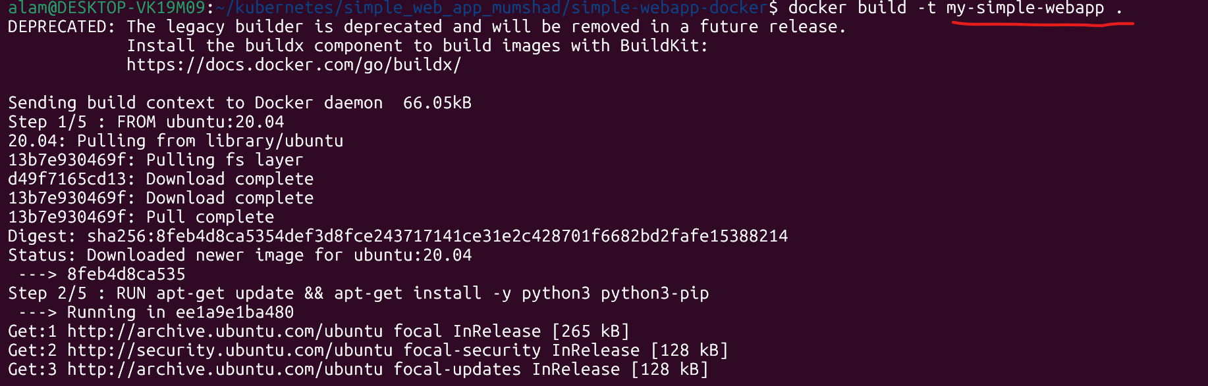

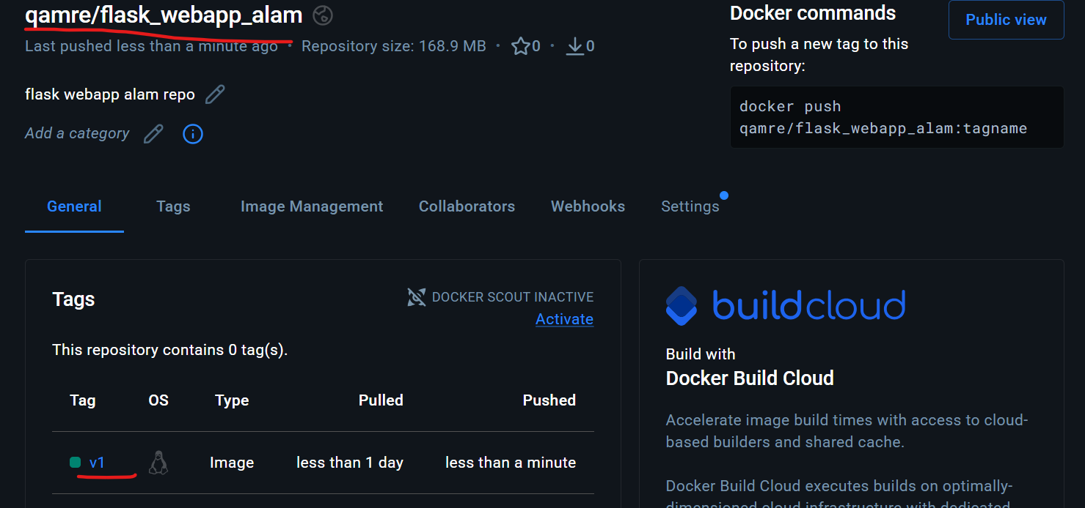

● Once Images are pushed to Docker hub registries, create a directory named kube.
Inside the kube directory create deployement.yaml file with 3 replication , labels app: flask-webapp , containerPort: 8080 and add the image that you have pushed in Docker Hub registry.

alam@DESKTOP-VK19M09:~/kubernetes/simple_web_app_mumshad/kube$ cat deployement.yaml
apiVersion: apps/v1
kind: Deployment
metadata:
name: flask-webapp-deployment
labels:
app: flask-webapp

spec:
replicas: 3

selector:
matchLabels:
app: flask-webapp

template:
metadata:
labels:
app: flask-webapp

spec:
containers:
- name: flask-webapp
image: qamre/flask_webapp_alam:v1
imagePullPolicy: Always

ports:
- containerPort: 8080

● Create one service.yaml file with type nodeport & select flask-webapp with port 8080 & targetPort 8080 with any nodePort between range 30000-32768.

alam@DESKTOP-VK19M09:~/kubernetes/simple_web_app_mumshad/kube$ cat service.yaml
apiVersion: v1
kind: Service
metadata:
name: flask-webapp-service
spec:
type: NodePort
selector:
app: flask-webapp
ports:
- protocol: TCP
port: 8080
targetPort: 8080
nodePort: 30080

● Once a service is created try accessing the web page in the browser as below. (30080 is nodeport mentioned in service.yaml). Meanwhile open app.py from your code to
understand paths & output.
http://master_ip:30080/
http:// 192.168.49.2:30080/how are you

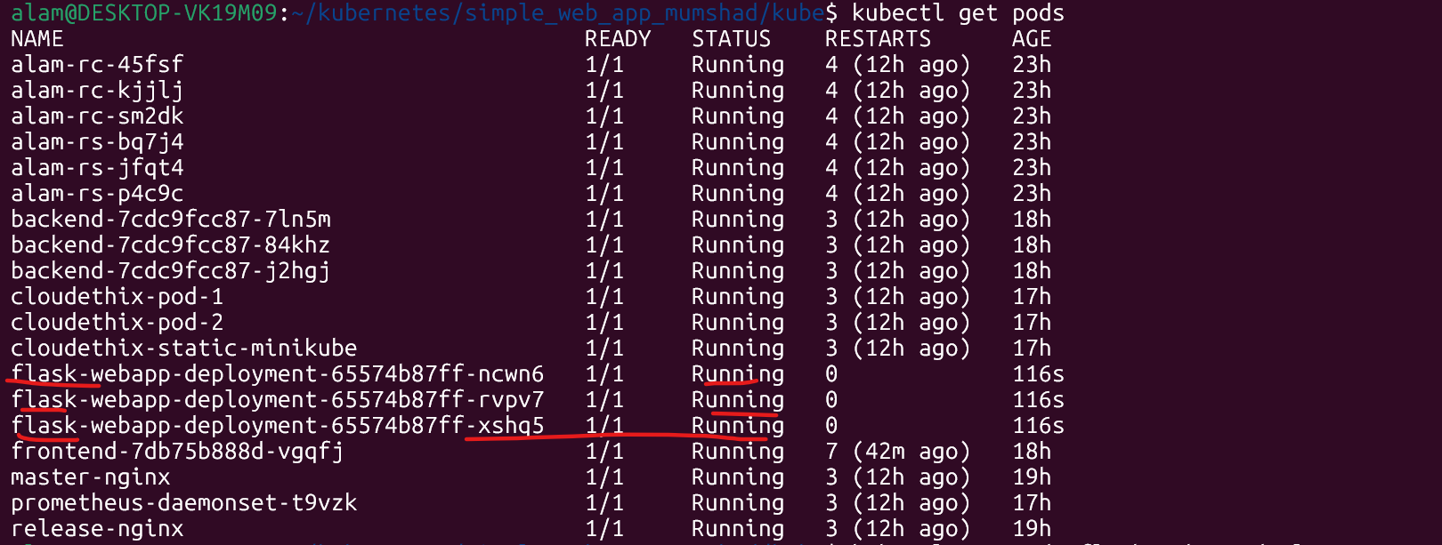

# minikube ip

● Now , update the app.py from your code and add below route above if __name__ ==
"__main__" line
@app.route('/Who are you')
def cloudethix():
return 'Yes, I am cloudethix, and You !!!'

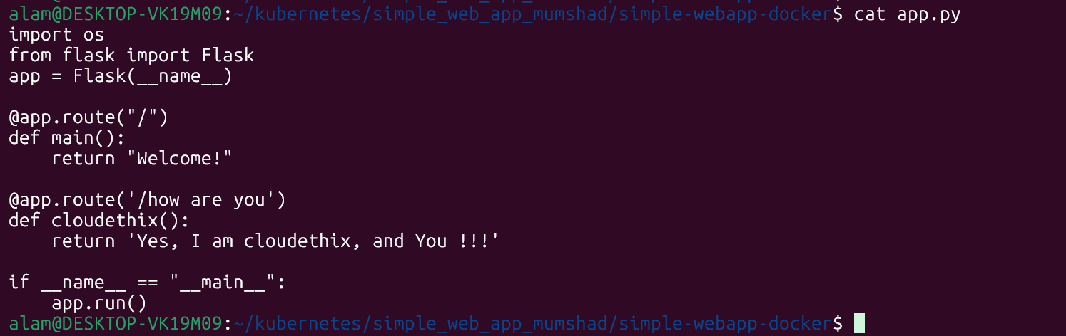

● Once the file is updated , rebuild the docker image & add meaningful tags with version 2 and push to Docker Hub registry.

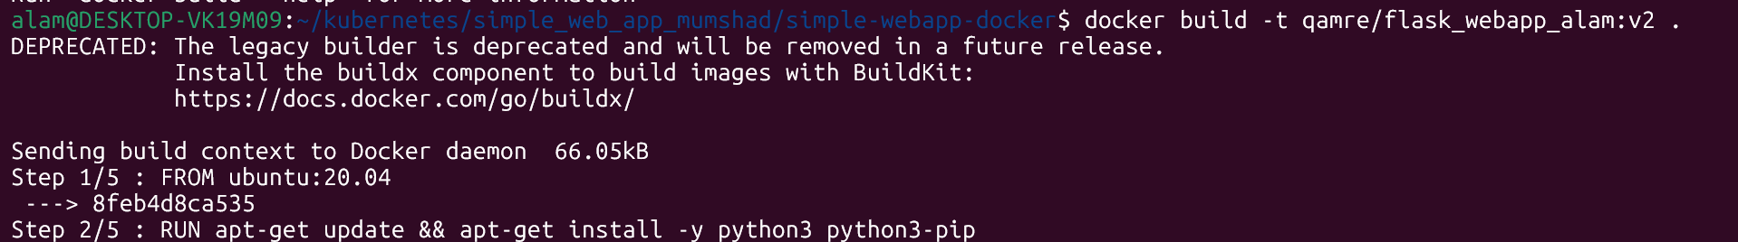

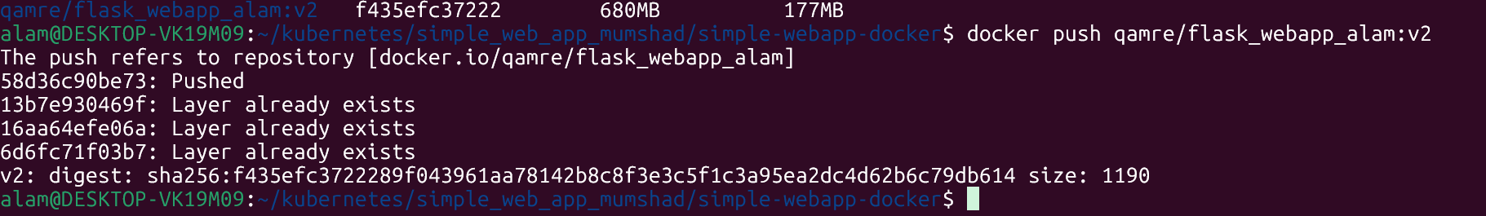

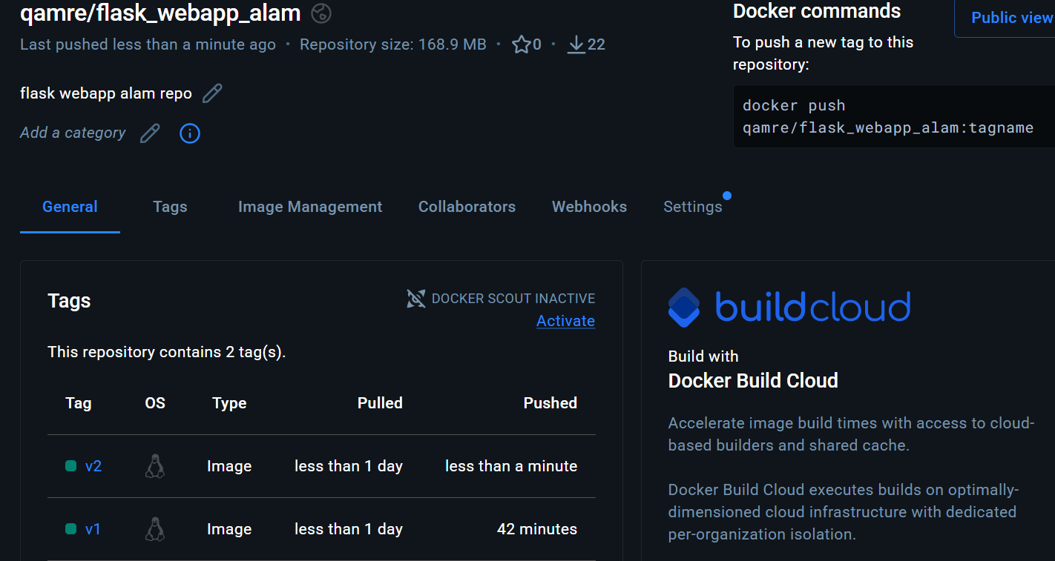

● Now we have the latest docker image in repo, It's time to roll out a new image. Roll out the new Image with all three ways one by one.

1. With kubectl set command
2. With kubectl edit deployment
3. With deployment.yaml file modification.

The kubectl set command is used to update specific properties of existing Kubernetes resources without editing the entire YAML file. It is commonly used to change a container image, environment variables, service account, or other configuration fields.

# kubectl set image flask-webapp-deployment-65574b87ff-ncwn6 qamre/flask_webapp_alam:v2
alam@DESKTOP-VK19M09:~/kubernetes/simple_web_app_mumshad/simple-webapp-docker$ kubectl set image deployment/flask-webapp-deployment \ flask-webapp=qamre/flask_webapp_alam:v2

● Run the # kubectl rollout command to check status and history.
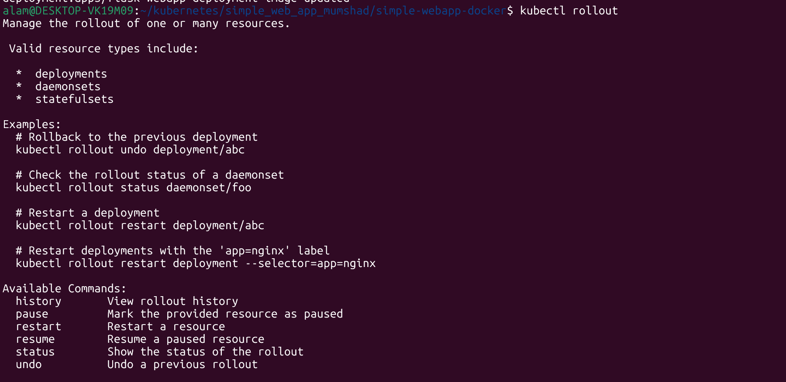

● Note:- Once above step 1 is done , run # kubectl rollout undo deployment command to
rollback the change and then try a second way of rollout.
# kubectl rollout undo deployment -- rollback the change

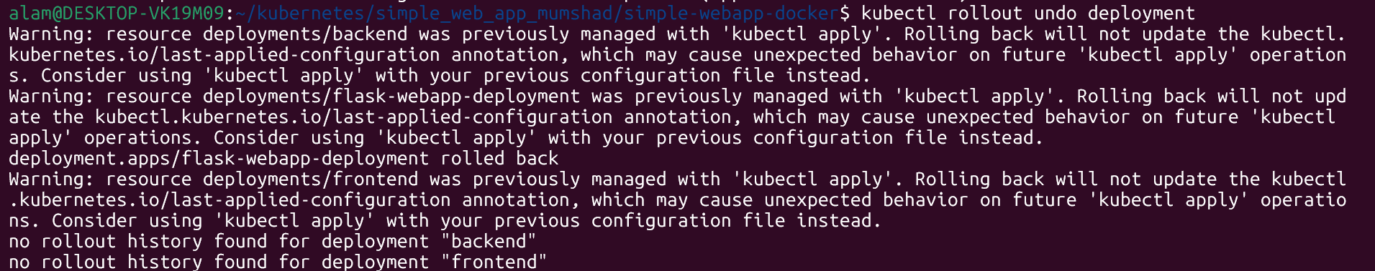

Note: - the rollback was successful. This error is as a information.

● In the browser run all three routes & notice the changes.
http://master_ip:30011/

http://master_ip:30011/how are you

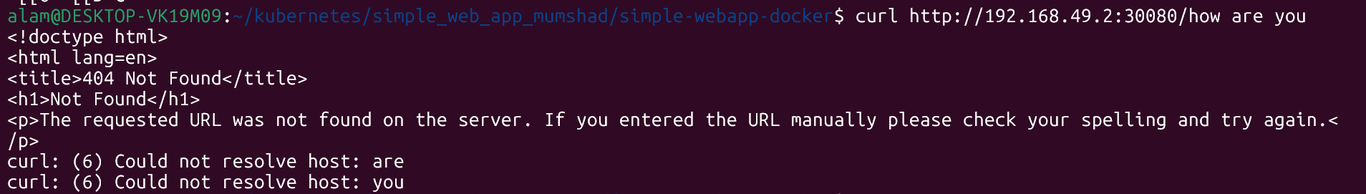

curl http://192.168.49.2:30080/how are you
The shell treats spaces as argument separators. So curl is actually interpreting it as:
- URL: http://192.168.49.2:30080/how
- Additional arguments: are and you
Since your Flask app does not have a /how route, it returns 404.
#So we will use as below to resolve the issue as below.

● Once done with all above steps, commit all the changes to the remote repository.
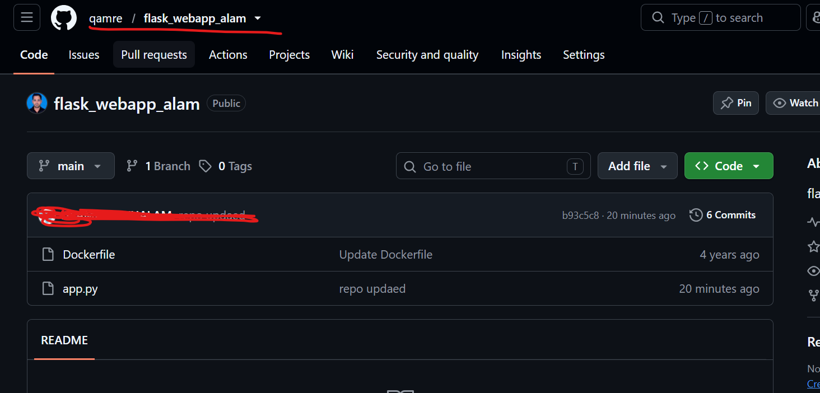

● Capture the snap and prepare a well formatted document.

Objective
The objective of this assignment is to learn how to containerize a Flask application, deploy it to Kubernetes, expose it through a NodePort Service, update the application, and perform rolling updates using three different methods. The exercise also demonstrates how to verify rollout status, view rollout history, and roll back to a previous application version when required.

This assignment demonstrates the complete application lifecycle using Docker and Kubernetes. A Flask application is first containerized and published to Docker Hub. It is then deployed to a Kubernetes cluster with three replicas and exposed through a NodePort Service for external access. After verifying the initial deployment, the application is enhanced by adding a new Flask route, rebuilding the image, and publishing a new version. Kubernetes rolling updates are then performed using three different approaches: kubectl set image, kubectl edit deployment, and updating the deployment manifest. During each update, Kubernetes replaces Pods gradually to ensure application availability with minimal downtime. Rollout status, history, and rollback features are used to monitor deployments and restore previous versions if necessary. This assignment highlights key DevOps concepts including containerization, versioned image management, Kubernetes Deployments, Services, rolling updates, rollback strategies, and Git-based source control.
==================================================================================
Que 2 →
● Download and install Lens & access your k8s cluster from Lens.
● Create nginx Pod and Nodeport service. Check the Pod logs from Lens.
● Check the service from lens. Also login to the pod shell using the lens.
● Take snaps and delete the resources that you have just created.

==================================================================================
Que 3 →
● Create 1 Public Docker Hub registry named cloudethix_configmap_yourname.
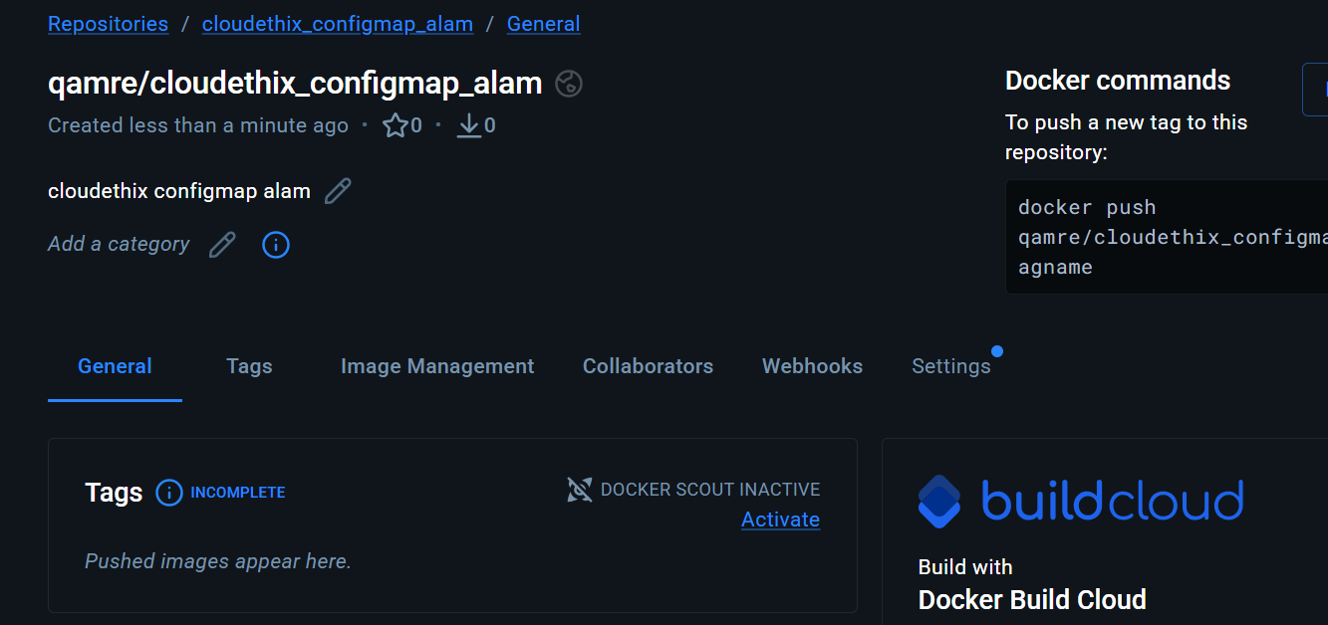

● Clone below repository on your system.
https://github.com/zembutsu/docker-sample-nginx.git

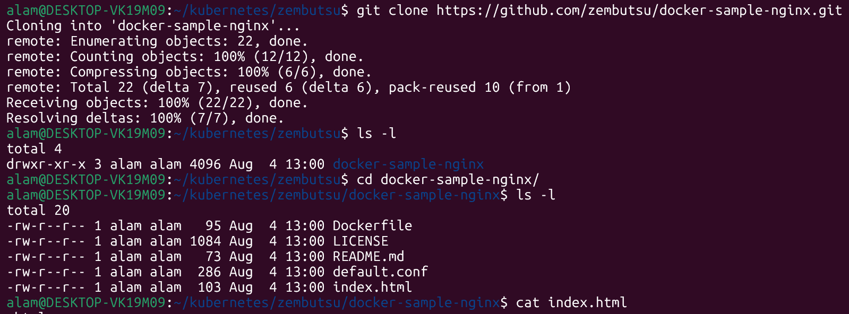

● Initialize a local repository & copy the code from above repo to your local repository in the working branch.

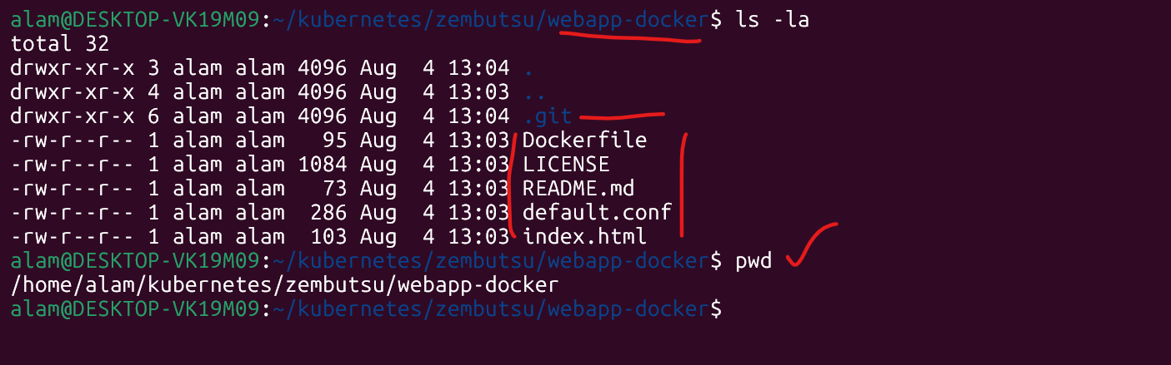

● Once code is copied , build a docker image from docker file and add meaningful tags and push to docker hub repository.

#docker build -t qamre/cloudethix_configmap_alam:v1 .
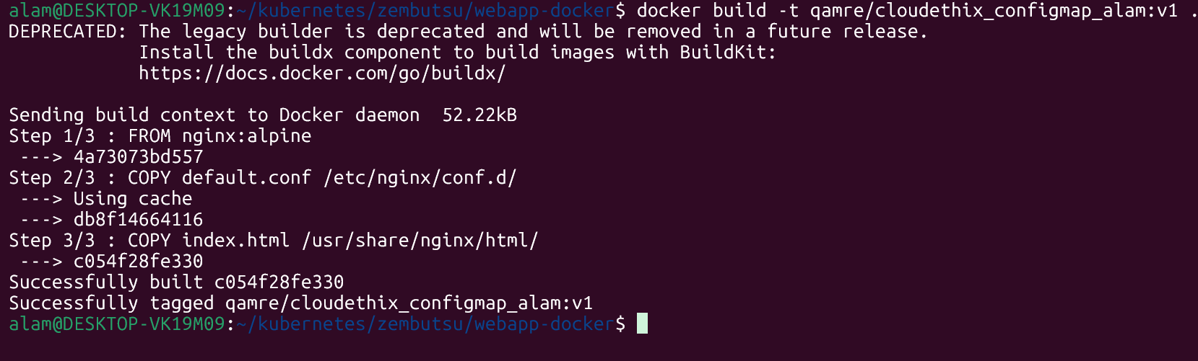

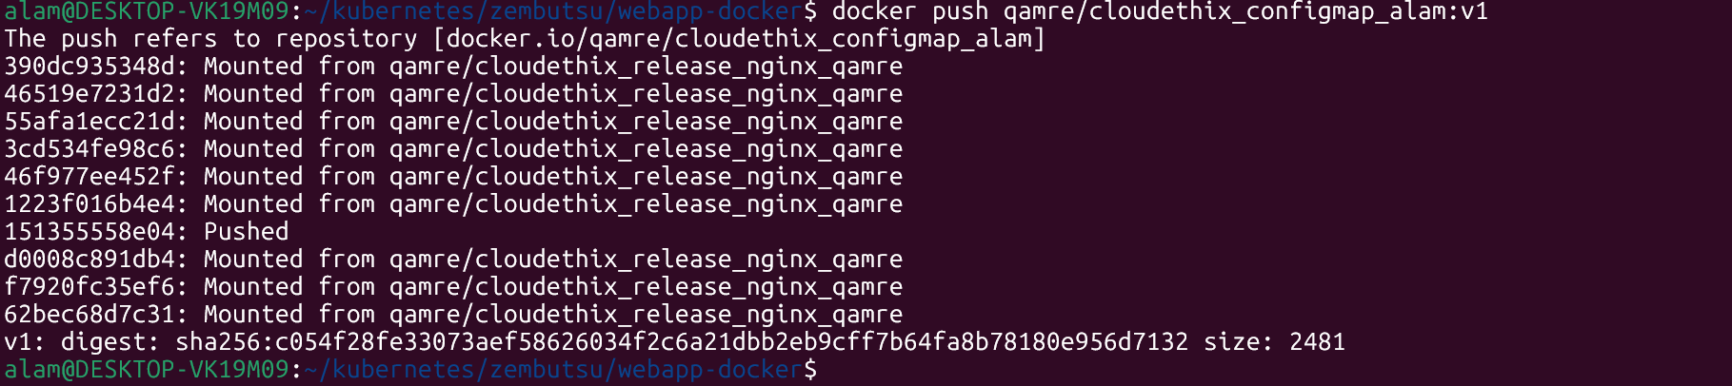

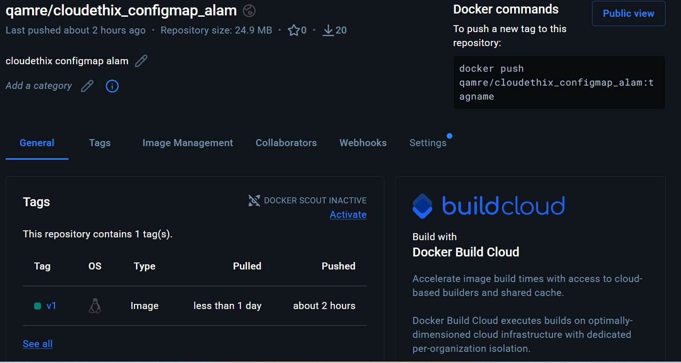
● Once Images are pushed to Docker hub registries, create a directory named kube.
Inside the kube directory create deployement.yaml file with 3 replication , labels app: frontend-webapp , containerPort: 80 and add the image that you have pushed in Docker Hub registry.

#kubectl get svc -A -- to chek which port are being open on k8s

/home/alam/kubernetes/kube

alam@DESKTOP-VK19M09:~/kubernetes/kube$ cat deployment.yaml
apiVersion: apps/v1
kind: Deployment
metadata:
name: frontend-webapp-deployment
labels:
app: frontend-webapp

spec:
replicas: 3

selector:
matchLabels:
app: frontend-webapp

template:
metadata:
labels:
app: frontend-webapp

spec:
containers:
- name: nginx
image: qamre/cloudethix_configmap_alam:v1/frontend-webapp:latest
imagePullPolicy: Always

ports:
- containerPort: 80

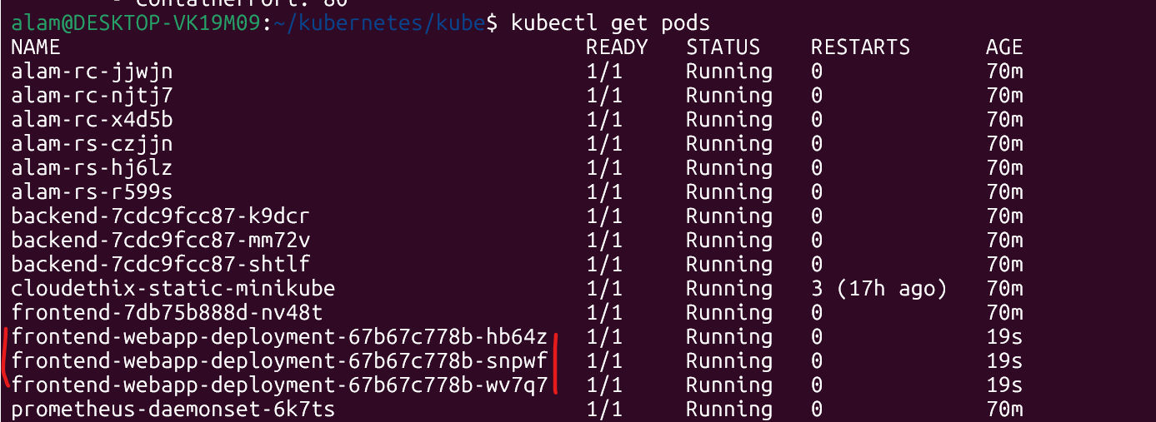

● Create one service.yaml file with type nodeport & select frontend-webapp pod with port 80 & targetPort 80 with any nodePort between range 30000-32768.

alam@DESKTOP-VK19M09:~/kubernetes/kube$ cat service.yaml
apiVersion: v1
kind: Service
metadata:
name: frontend-webapp-service

spec:
type: NodePort

selector:
app: frontend-webapp

ports:
- protocol: TCP
port: 80
targetPort: 80
nodePort: 30080

● Once the service is created try accessing the web page in the browser as below. Notice the changes & take the snap.

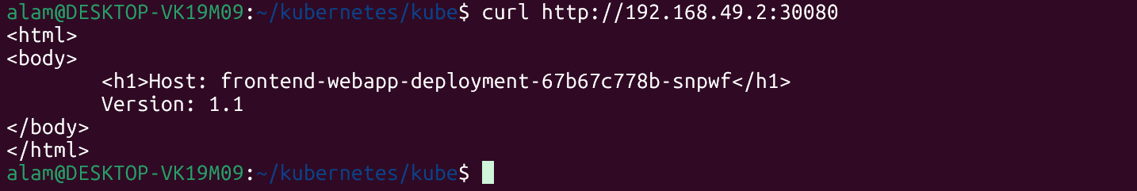

● Now create a configmap.yaml file with below data & delete the deployment that you have created.
<html>
<body>
<h1> I am Cloudethix Team, Are you ?!! </h1>
Version: 1.1
</body>
</html>

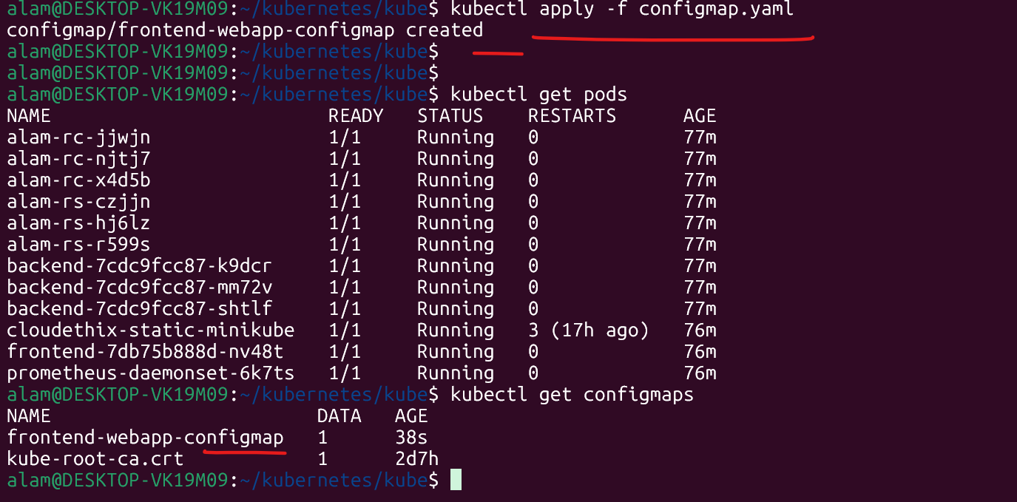

● Then update the same deployment.yaml file and mount configmap as volume on
container using volumeMounts with mountPath /usr/share/nginx/html/

apiVersion: apps/v1
kind: Deployment
metadata:
name: frontend-webapp-deployment
labels:
app: frontend-webapp

spec:
replicas: 3

selector:
matchLabels:
app: frontend-webapp

template:
metadata:
labels:
app: frontend-webapp

spec:
containers:
- name: nginx
image: qamre/cloudethix_configmap_alam:v1
imagePullPolicy: Always

ports:
- containerPort: 80

volumeMounts:
- name: html-volume
mountPath: /usr/share/nginx/html

volumes:
- name: html-volume
configMap:
name: frontend-webapp-configmap

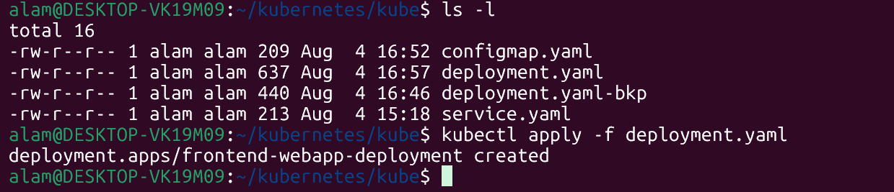

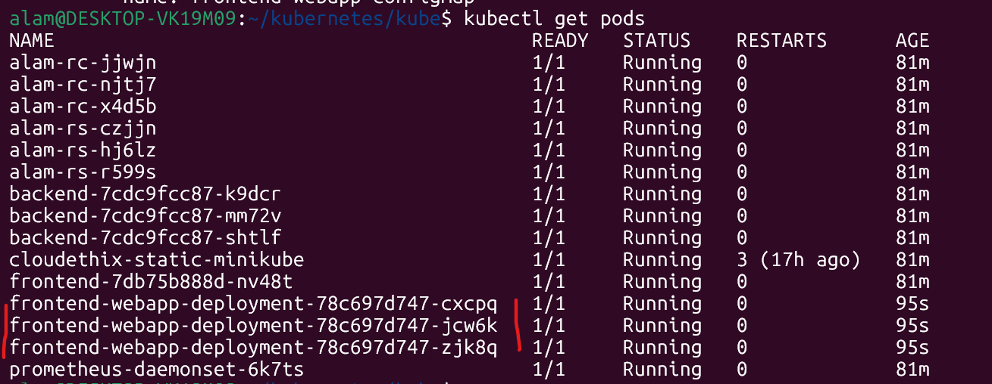

● Now it's time to create configmap & deployment. Once created , try to access the webpage in the browser & confirm that the index page is the same as we have in
configmap.

configmap.yaml -- se the output as below.
<html>
<body>
<h1> I am Cloudethix Team, Are you ?!! </h1>
Version: 1.1
</body>
</html>

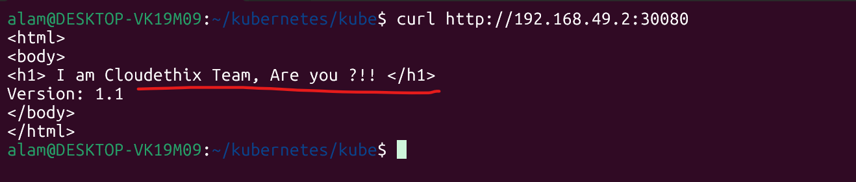

Objective
The objective of this assignment is to understand how Kubernetes ConfigMaps are used to externalize application configuration and static content from container images. In this exercise, an Nginx application is containerized, deployed on Kubernetes, exposed using a NodePort Service, and then updated to serve a custom HTML page using a ConfigMap mounted as a volume.

Take away from this project
This assignment demonstrates how Kubernetes ConfigMaps help separate configuration data from application containers. Initially, the Nginx application serves its default web page from the container image. After creating a ConfigMap containing custom HTML content, the Deployment is modified to mount the ConfigMap as a volume inside the Nginx document root (/usr/share/nginx/html/). Kubernetes injects the ConfigMap data into the running Pods, allowing the application content to be changed without rebuilding the Docker image. This approach improves application flexibility, simplifies configuration management, and follows Kubernetes best practices for managing environment-specific configuration and static files.

==================================================================================
Que 4 →

● Create 1 Public Docker Hub registry named cloudethix_multicontainer_yourname.
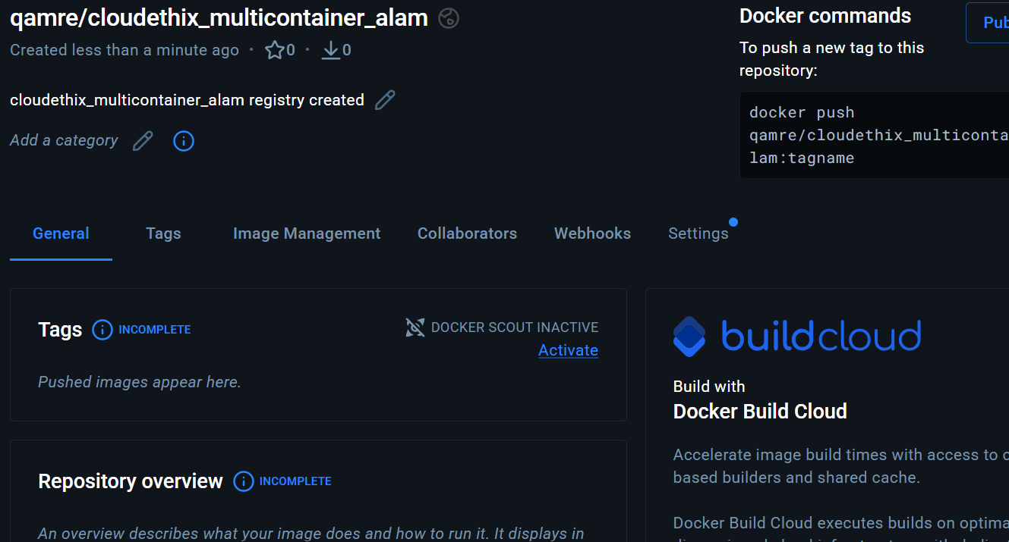

● Clone below repository on your system.
https://github.com/janakiramm/Kubernetes-multi-container-pod.git

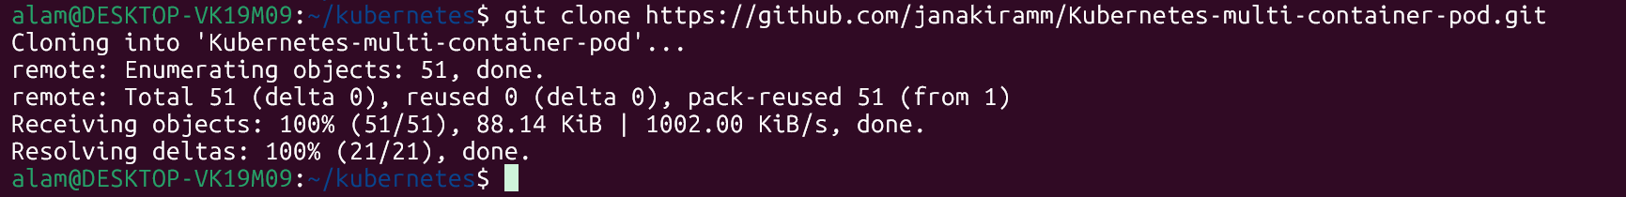

● Initialize a local repository & copy the code from above repo to your local repository in any of your working branches.

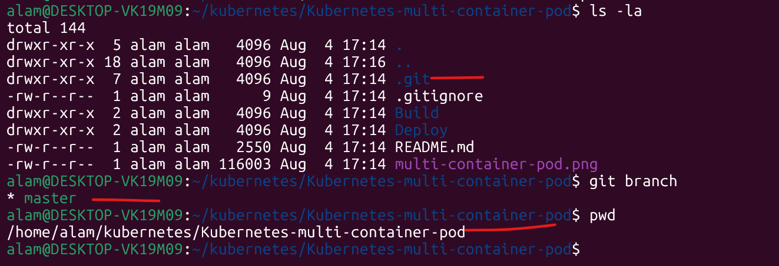

● Once code is copied, go to the Build directory and build docker image from docker file and add meaningful tags and push to docker hub repository.

#docker build -t qamre/ cloudethix_multicontainer_alam:v1 . Or
#docker build -t multicontainer:latest .

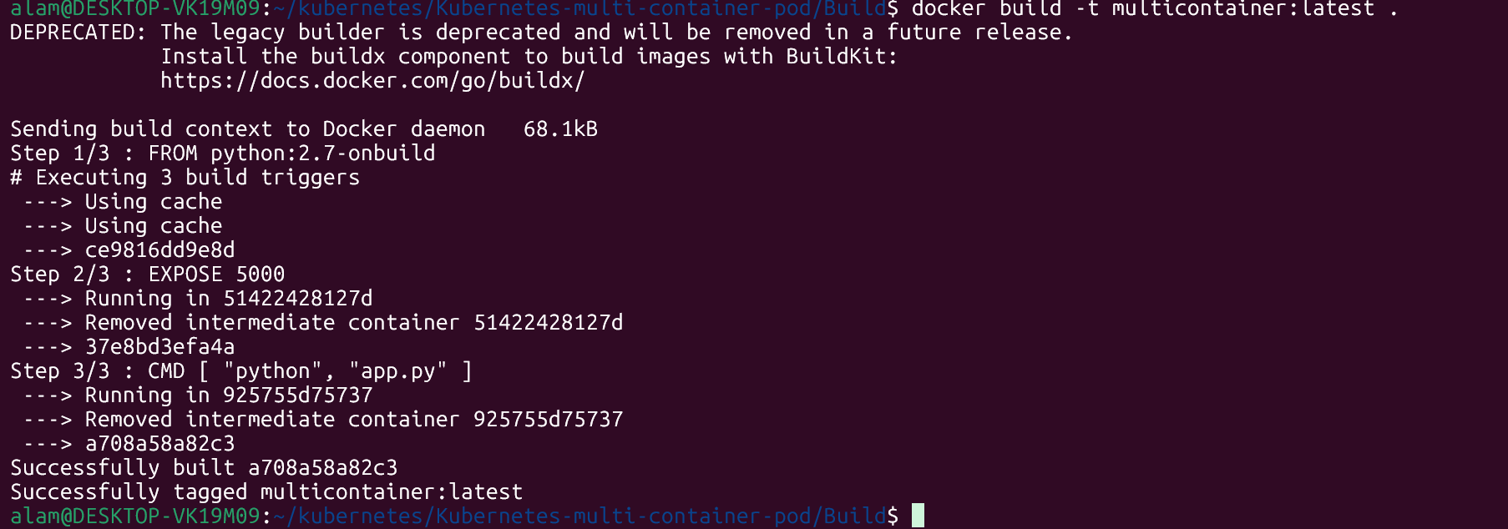

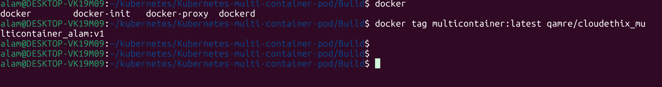

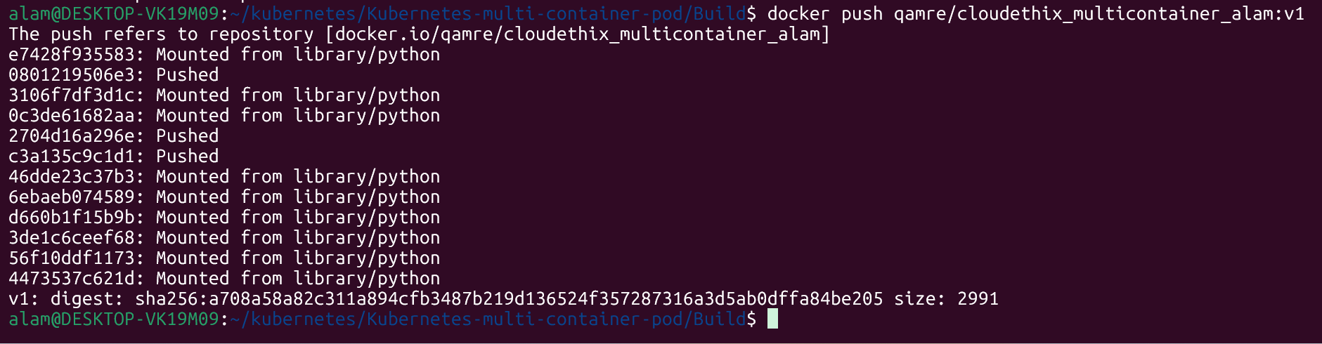

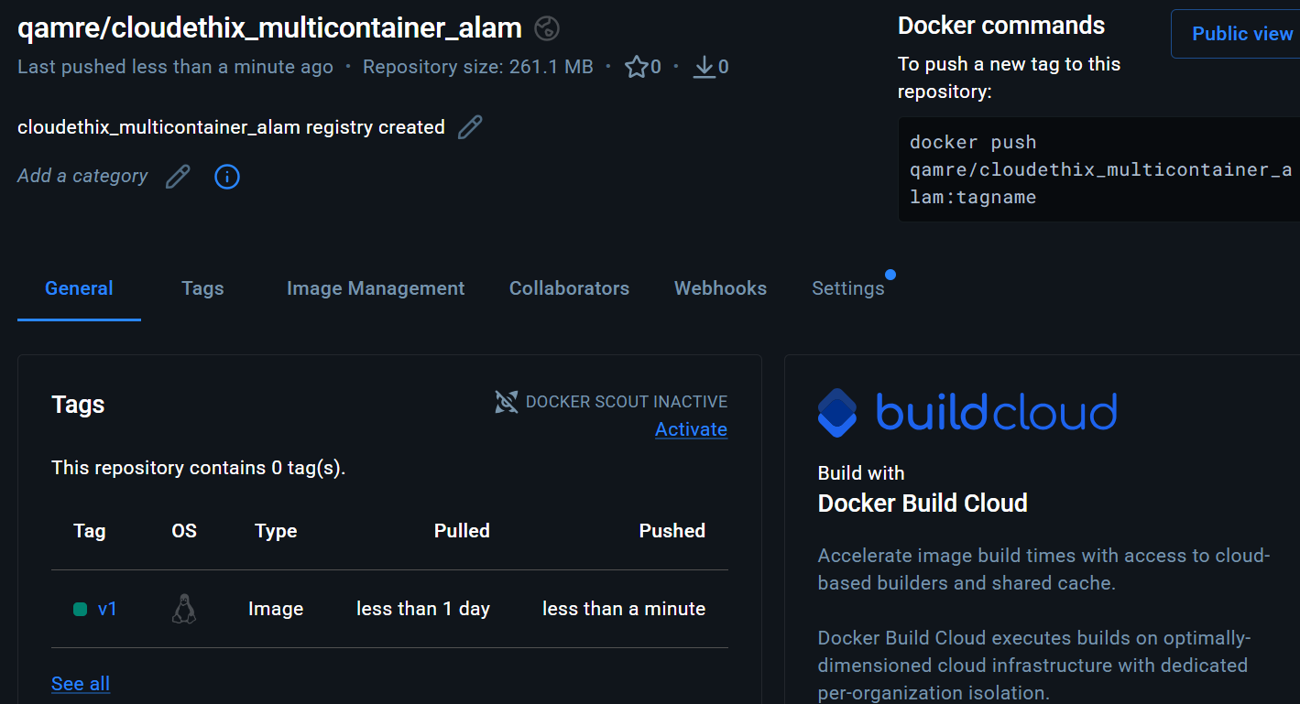

● Now go to the deploy directory and notice the files.

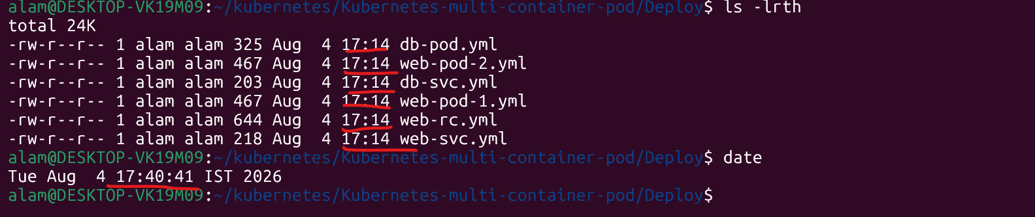

● Here, web-pod-1.yml file will create the pod with two containers (Multi container). Take a note of lables , name of containers and ports. Also, please make sure you will update the python container image that you have pushed to your docker registry.

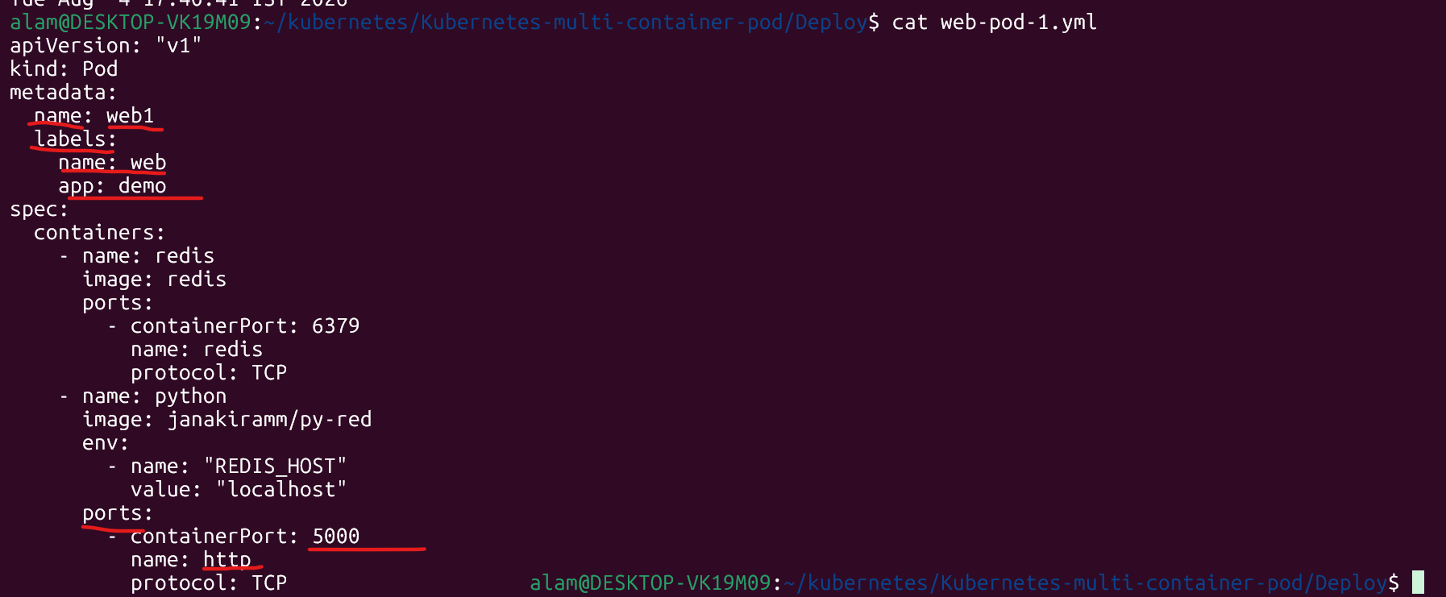

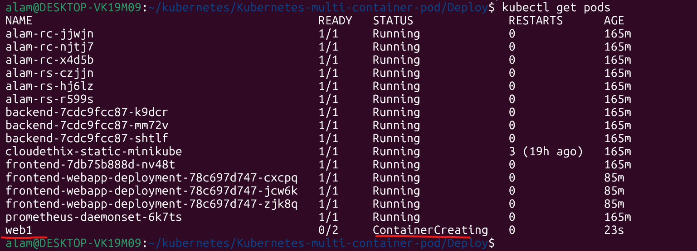

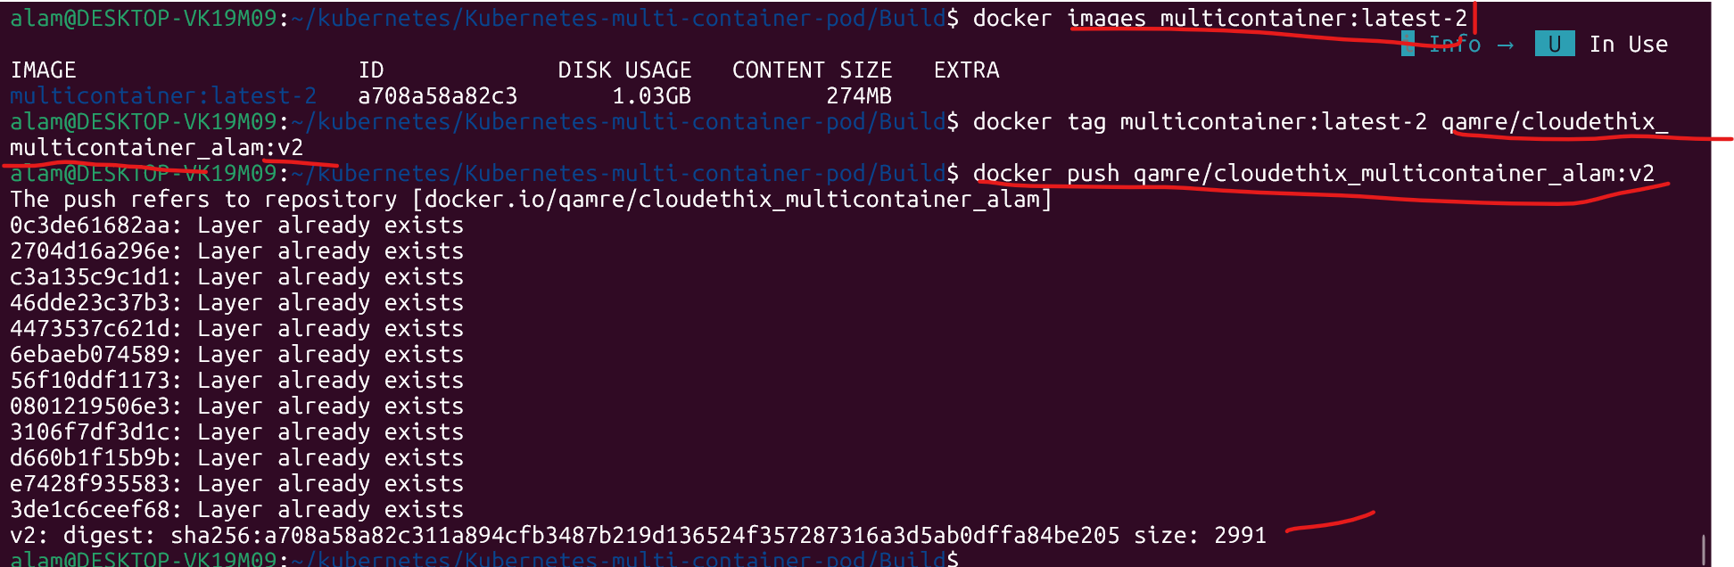

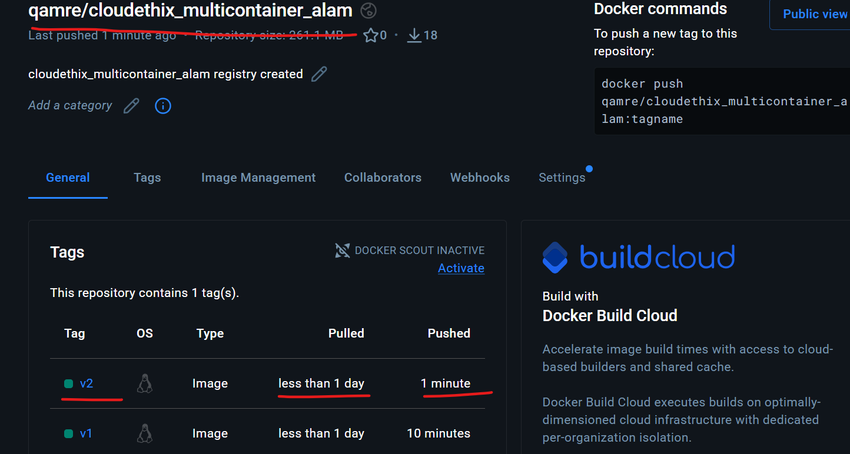

● Now, open web-svc.yml file and notice service Type , selectors & targetPort. Apply the file.
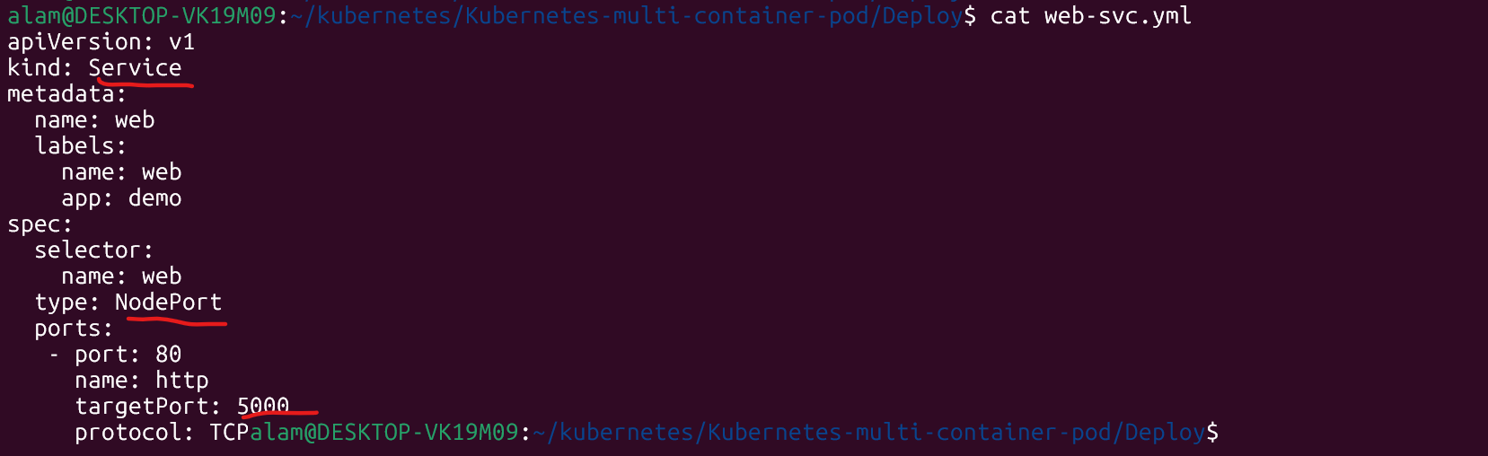

# kubectl apply -f web-svc.yml
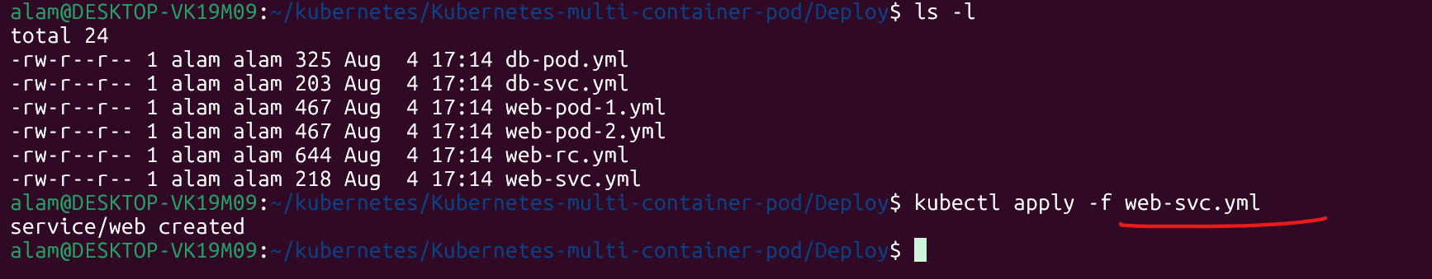

Verify
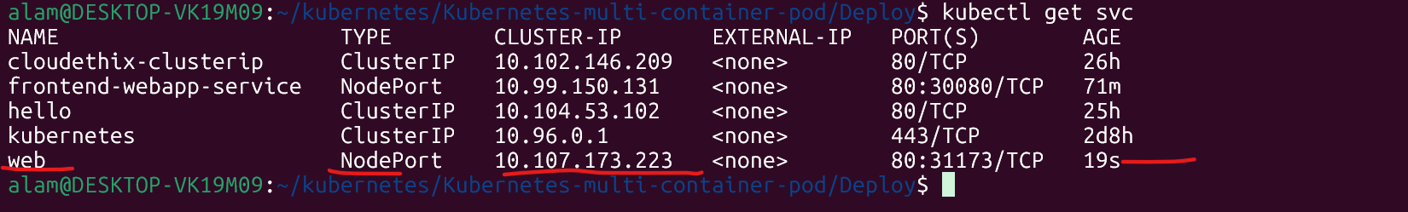

● Now open db-pod.yml & notice the lables , name , Image, containerPort and apply the file.

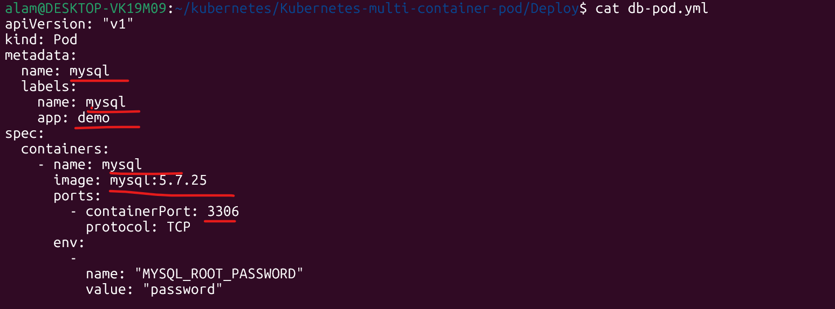

● Now open the db-svc.yml file and notice service Type , selectors & targetPort. Apply the file.
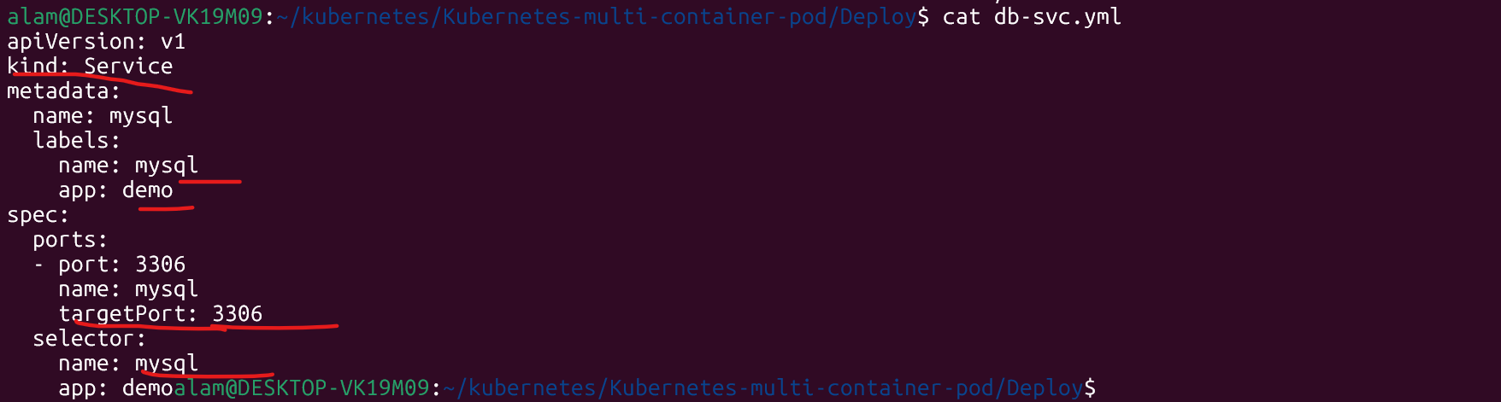

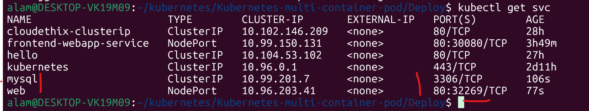

● Once above files are applied , Check that the Pods and Services are created using command line or lens.



● Now , from the command line run below urls & notice the changes.
# curl http://$NODE_IP:$NODE_PORT/init
Initialize the database with sample schema

# curl http://192.168.49.2:32269/init

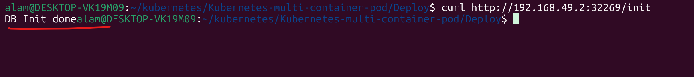

● Now it's time to Insert some sample data. Make sure you will use correct

$NODE_IP:$NODE_PORT

# curl -i -H "Content-Type: application/json" -X POST -d '{"uid": "1",
"user":"John Doe"}' http://192.168.49.2:32269/users/add

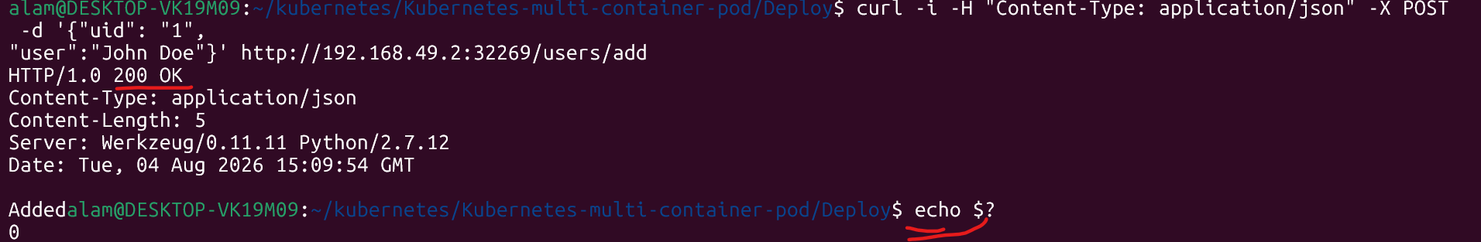

# curl -i -H "Content-Type: application/json" -X POST -d '{"uid": "2",
"user":"Jane Doe"}' http://192.168.49.2:32269/users/add

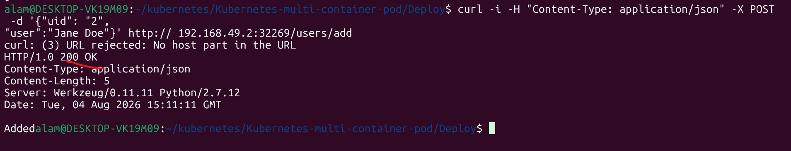

# curl -i -H "Content-Type: application/json" -X POST -d '{"uid": "3",
"user":"Bill Colls"}' http://192.168.49.2:32269/users/add

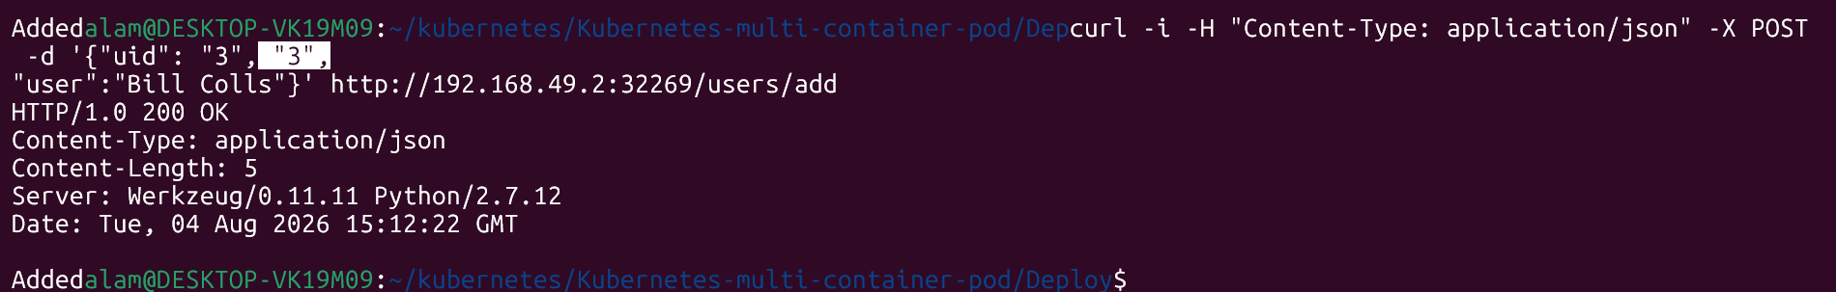

# curl -i -H "Content-Type: application/json" -X POST -d '{"uid": "4",
"user":"Mike Taylor"}' http://192.168.49.2:32269/users/add

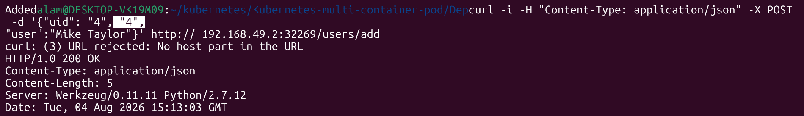

● Now access the data that we have added to database using below command.
# curl http://192.168.49.2:32269/users/1

● The second time you access the data, it appends '(c)' indicating that it is pulled from the Redis cache.

● Also, try to access mysql shell i.e db pod & run select * from the users table. Check app.py for DB related information.

#kubectl exec -it mysql -- mysql -u root -p
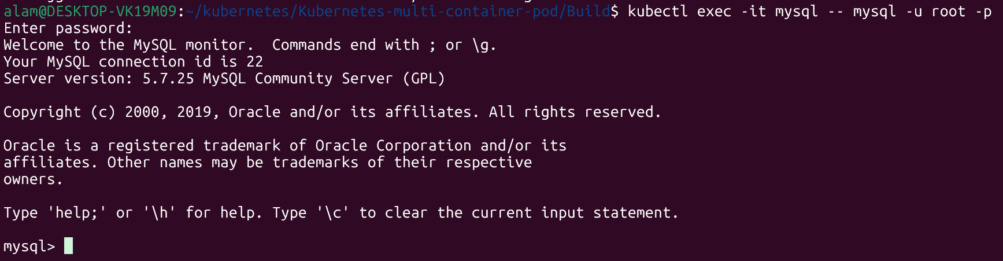

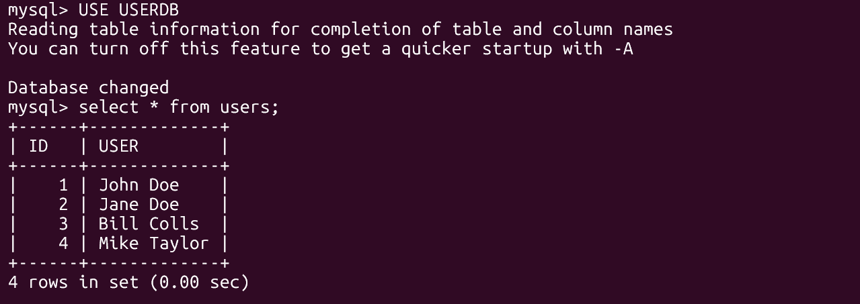

● Prepare poper documentation in brief & write start to end flow. Refer below link if you face any issues.
https://github.com/janakiramm/Kubernetes-multi-container-pod

Multi-Container Pods in Kubernetes
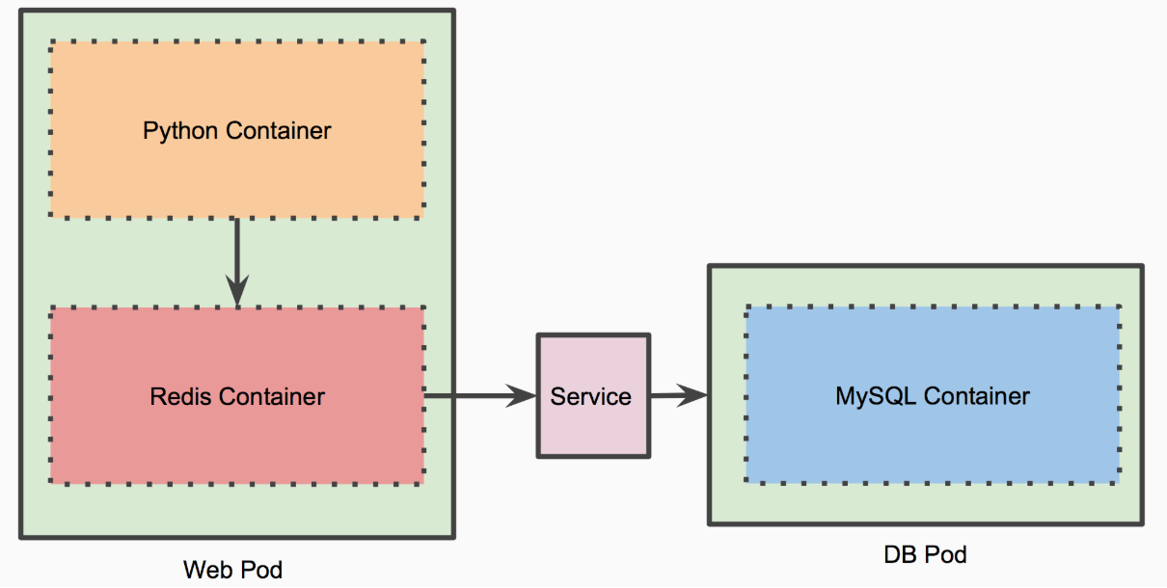

Objective :
The objective of this assignment is to understand how a multi-container Pod works in Kubernetes. The application consists of a Python web application and a Redis cache running in the same Pod, while MySQL runs in a separate Pod. The exercise demonstrates container communication, Kubernetes Services, data persistence, and caching using Redis.
Understanding
This assignment demonstrates a multi-container Pod architecture in Kubernetes. The web Pod contains two tightly coupled containers: a Python web application and a Redis cache. Since both containers run in the same Pod, they share the same network namespace and can communicate efficiently over localhost. A separate MySQL Pod stores persistent user data and is accessed through a Kubernetes Service. After the application initializes the database and inserts user records, the first request retrieves data from MySQL and stores it in Redis. Subsequent requests are served from the Redis cache, reducing database access and improving performance, which is indicated by the (c) suffix in the response. This exercise highlights Kubernetes concepts such as multi-container Pods, Services, inter-container communication, caching strategies, and database connectivity in a microservices-based application.

======================================================================
Que 5 →
● Create 1 Public Docker Hub registry named cloudethix_Initcontainer_yourname.

Repo: - qamre/cloudethix_initcontainer_alam
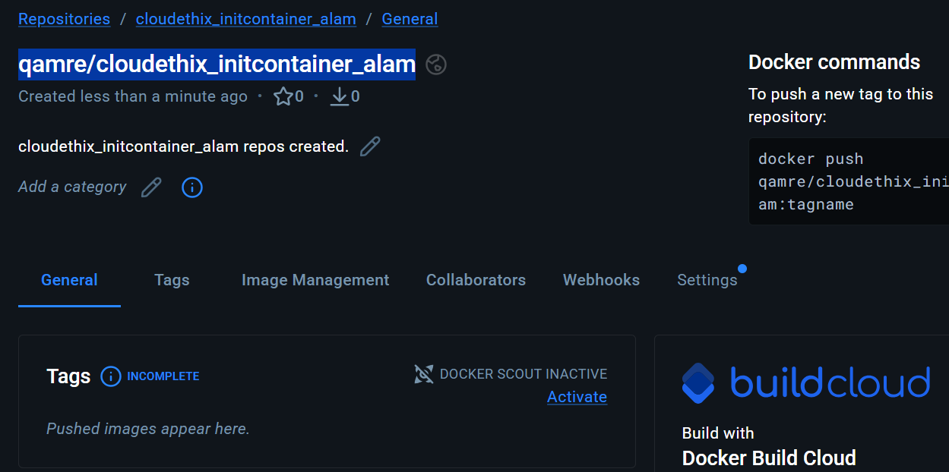

● Clone below repository on your system.
https://github.com/janakiramm/simpleapp.git

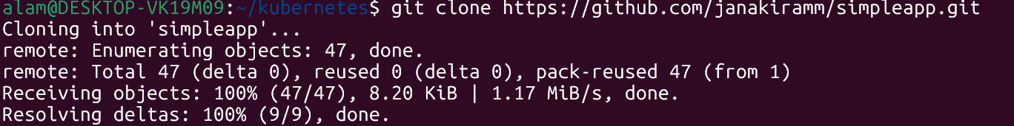
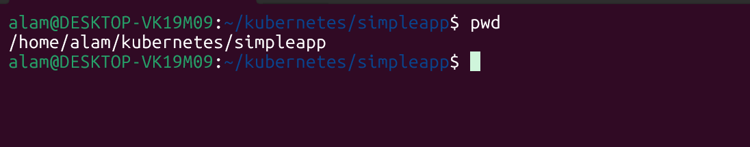

● Initialize a local repository & copy the code from above repo to your local repository in any of your working branch.

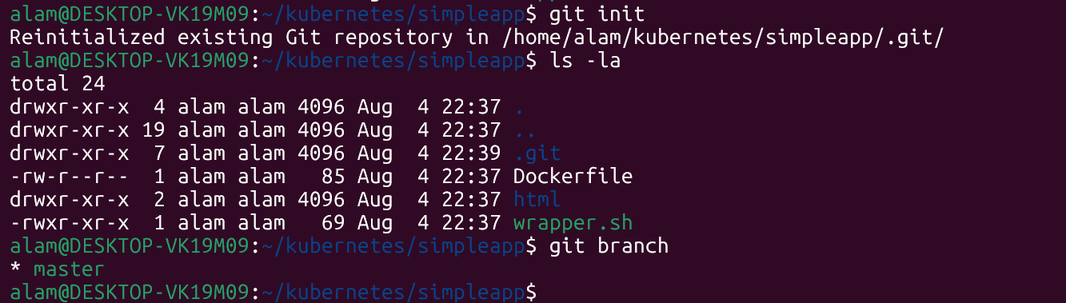
● Once code is copied , go to the Build directory and build docker image from docker file and add meaningful tags and push to docker hub repository.
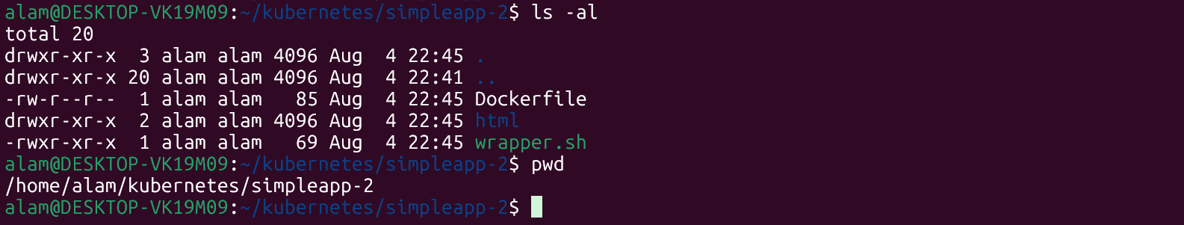

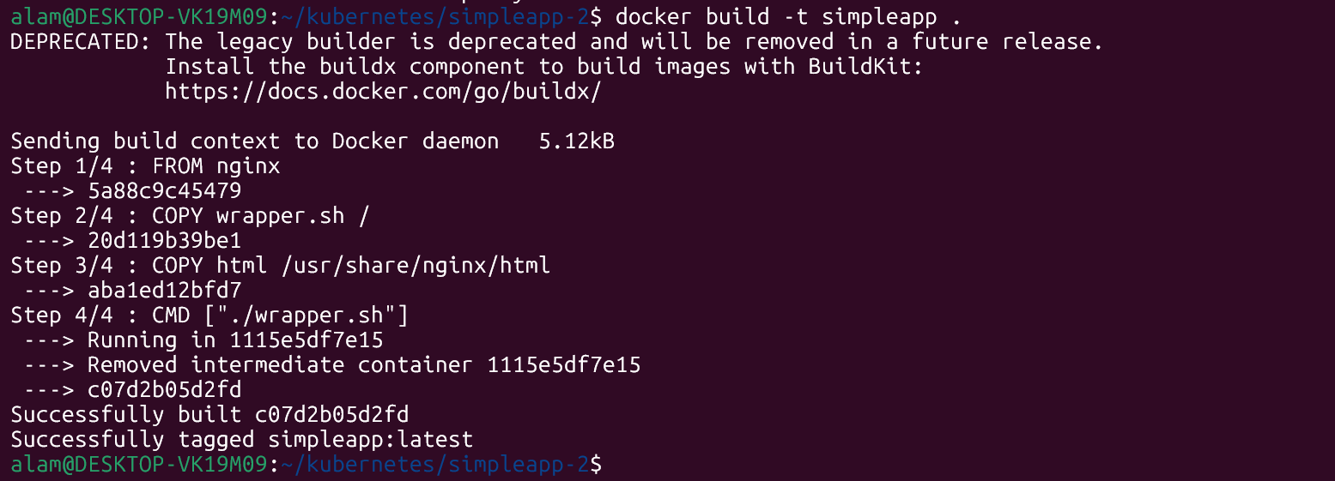
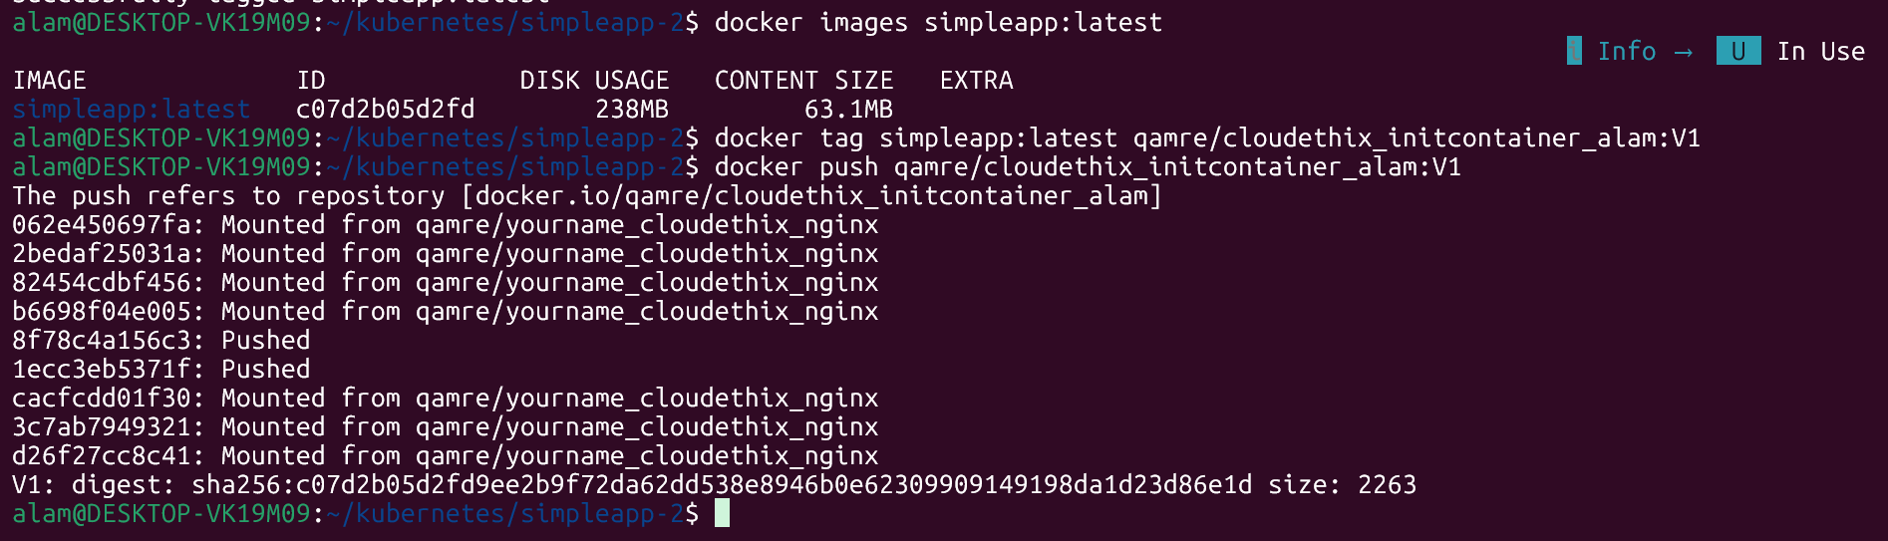

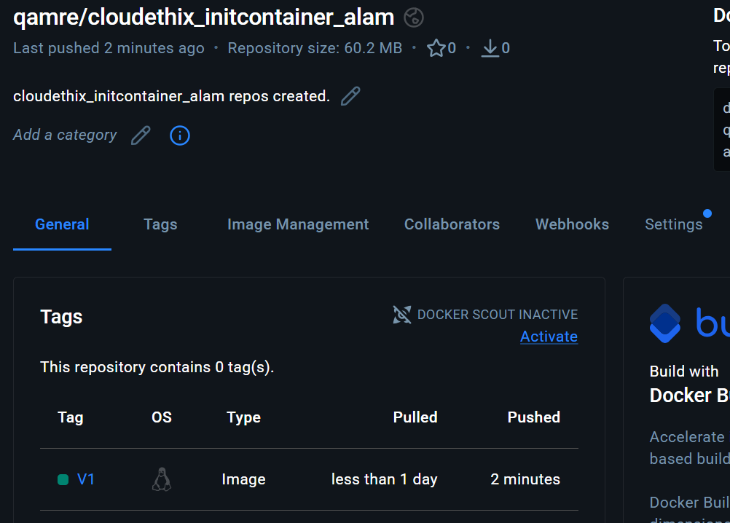

● Once Images are pushed to Docker hub registries, create a directory named kube.
Inside the kube directory create deployement.yaml file with 3 replication , label app:simpleapp-webapp , containerPort:80 and add the image that you have pushed in
Docker Hub registry.

# deployement.yaml
alam@DESKTOP-VK19M09:~/kubernetes/kube$ cat deployement.yaml
apiVersion: apps/v1
kind: Deployment
metadata:
name: simpleapp-webapp
labels:
app: simpleapp-webapp
spec:
replicas: 3
selector:
matchLabels:
app: simpleapp-webapp
template:
metadata:
labels:
app: simpleapp-webapp
spec:
containers:
- name: simpleapp-webapp
image: qamre/cloudethix_initcontainer_alam:V1
ports:
- containerPort: 80

● Create one service.yaml file with type nodeport & select simpleapp-webapp pod with port 80 & targetPort 80 with any nodePort between range 30000-32768.

#cat service.yaml
apiVersion: v1
kind: Service
metadata:
name: simpleapp-webapp-service
spec:
type: NodePort
selector:
app: simpleapp-webapp
ports:
- protocol: TCP
port: 80
targetPort: 80
nodePort: 30080

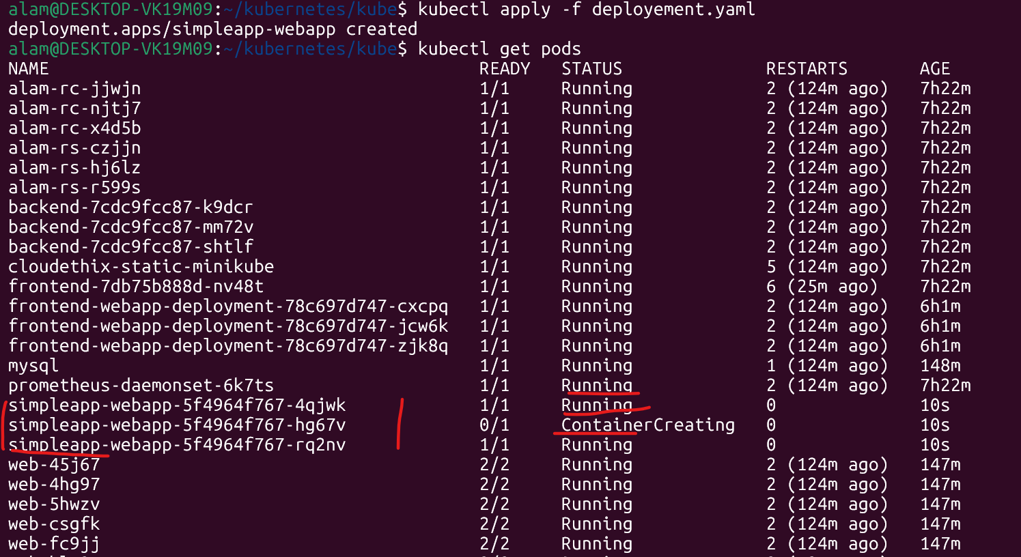

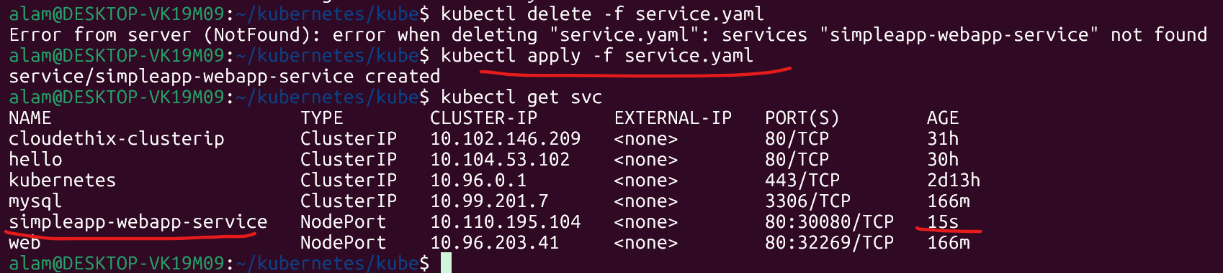

● Open the webpage in the browser and notice the changes and capture the snap.

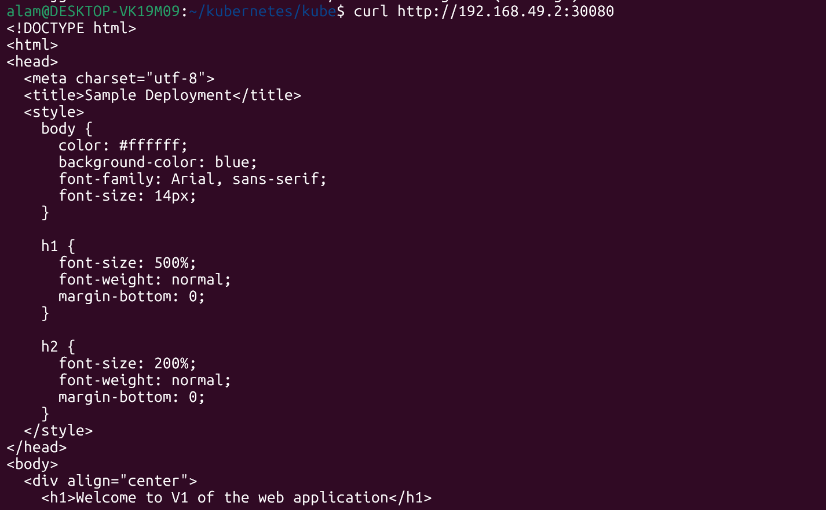

● Then delete the deployment that you have just created.
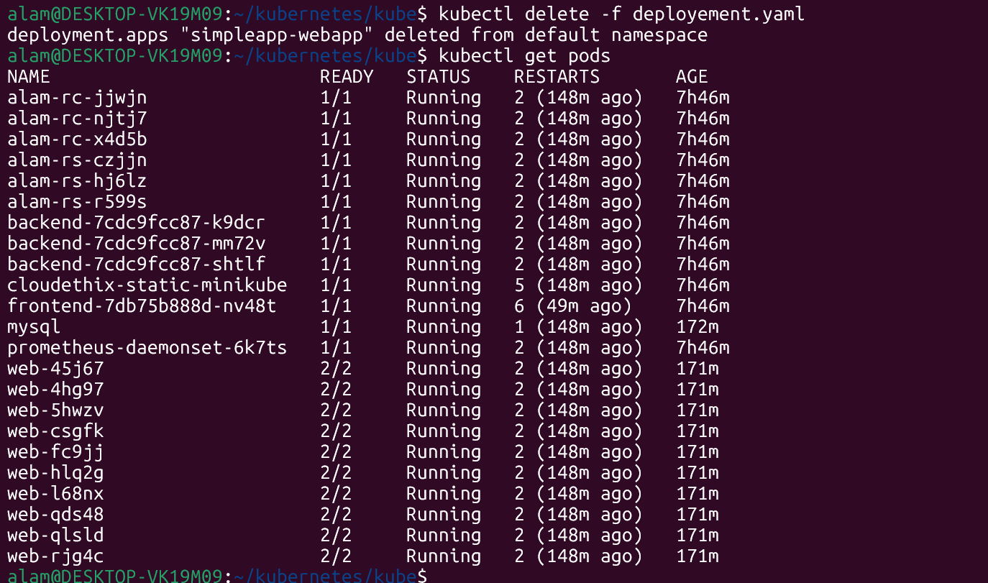

● Update the deployment.yaml file and add volumeMounts with mountPath
/usr/share/nginx/html from emptyDir: {} volume.

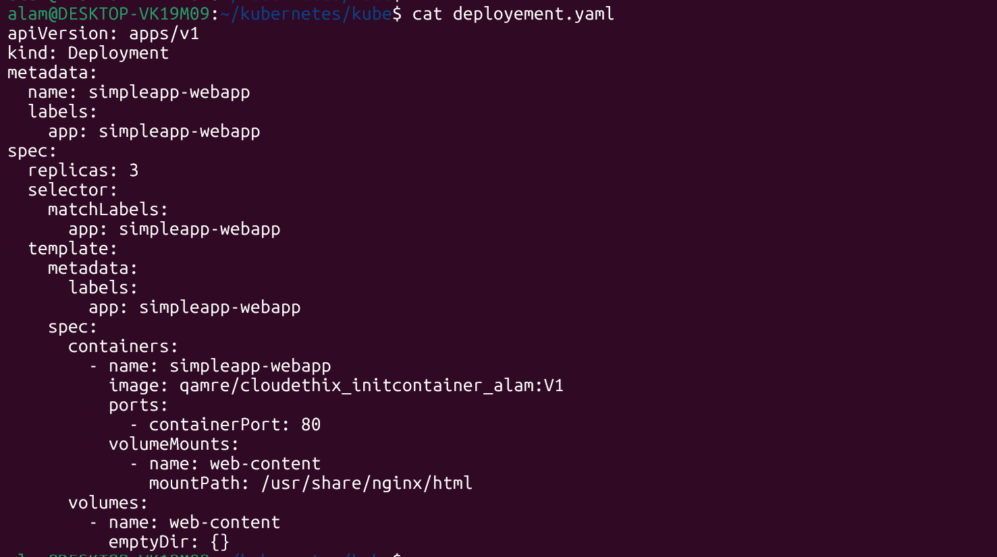

● Once above changes are added, add initContainers block with below parameters. Also add volumeMounts for Init Container with mountPath "/work-dir" from emptyDir: {}
volume.
initContainers:
- name: install
image: busybox:1.28
command:
- wget
- "-O"
- "/work-dir/index.html"
- http://info.cern.ch
volumeMounts:
- name: workdir
mountPath: "/work-dir"

# cat deployment.yaml

apiVersion: apps/v1
kind: Deployment
metadata:
name: simpleapp-webapp
labels:
app: simpleapp-webapp
spec:
replicas: 3
selector:
matchLabels:
app: simpleapp-webapp
template:
metadata:
labels:
app: simpleapp-webapp
spec:
initContainers:
- name: install
image: busybox:1.28
command:
- wget
- "-O"
- "/work-dir/index.html"
- "http://info.cern.ch"
volumeMounts:
- name: workdir
mountPath: "/work-dir"

containers:
- name: simpleapp-webapp
image: qamre/cloudethix_initcontainer_alam:V1
ports:
- containerPort: 80
volumeMounts:
- name: workdir
mountPath: "/usr/share/nginx/html"

volumes:
- name: workdir
emptyDir: {}

● Add volumes with emptyDir: {} in deployment.yaml file.

apiVersion: apps/v1
kind: Deployment
metadata:
name: simpleapp-webapp
labels:
app: simpleapp-webapp
spec:
replicas: 3
selector:
matchLabels:
app: simpleapp-webapp
template:
metadata:
labels:
app: simpleapp-webapp
spec:
volumes:
- name: workdir
emptyDir: {}

initContainers:
- name: install
image: busybox:1.28
command:
- wget
- "-O"
- "/work-dir/index.html"
- "http://info.cern.ch"
volumeMounts:
- name: workdir
mountPath: "/work-dir"

containers:
- name: simpleapp-webapp
image: qamre/cloudethix_initcontainer_alam:V1
ports:
- containerPort: 80
volumeMounts:
- name: workdir
mountPath: "/usr/share/nginx/html"

● Once the deployment.yaml file is ready, create the deployment & access the page in the browser and notice the changes.

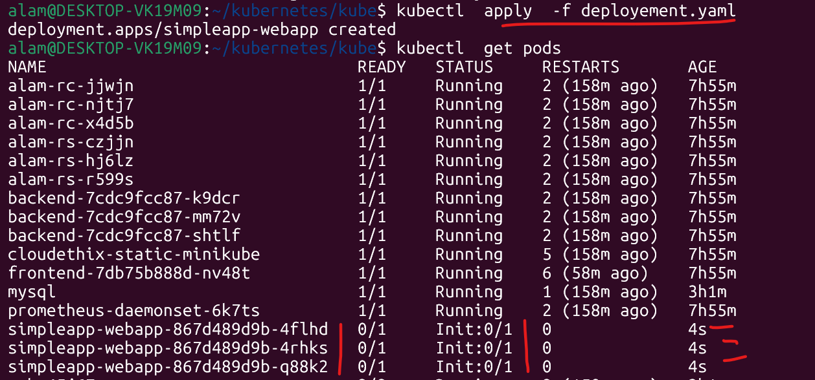

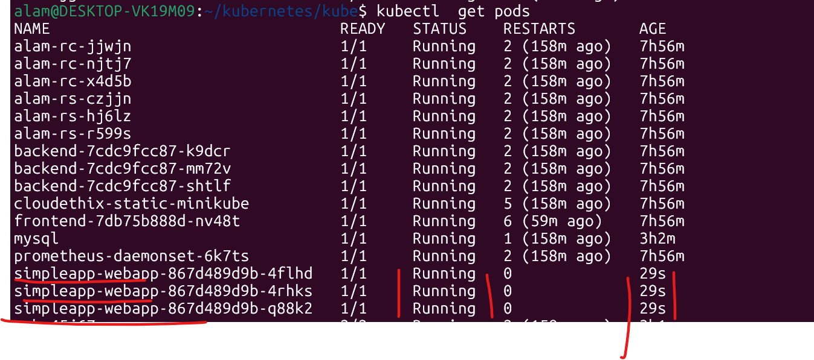
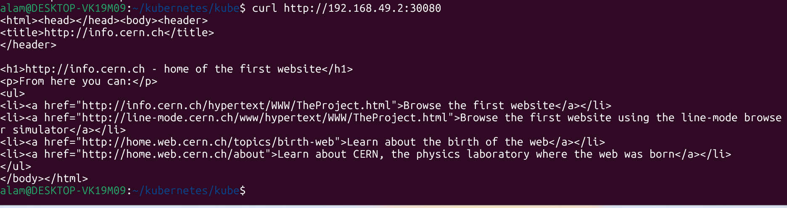

● Prepare a well formatted document and write your understanding step by step.

Objective
The objective of this assignment is to learn how Init Containers work in Kubernetes by deploying a web application, exposing it through a NodePort Service, and then modifying the Deployment to use an Init Container and an emptyDir volume. The Init Container downloads web content before the main application container starts, demonstrating container initialization and shared storage.

Understanding of the Assignment
This assignment demonstrates how Kubernetes Init Containers prepare an application environment before the main application starts. First, the application is containerized, published to Docker Hub, and deployed with three replicas behind a NodePort Service. After confirming the application is accessible, the Deployment is enhanced with a shared emptyDir volume and an Init Container. The Init Container runs before the main Nginx container, downloads the index.html file from http://info.cern.ch, and stores it in the shared volume. The main container mounts the same volume at /usr/share/nginx/html, allowing it to serve the downloaded content. This illustrates how Init Containers can perform setup tasks such as downloading files, generating configuration, or preparing shared data before the primary application starts, enabling clean separation of initialization logic from the main workload.

Que 6 →
● Create 1 Public Docker Hub registry named cloudethix_hpa_yourname.
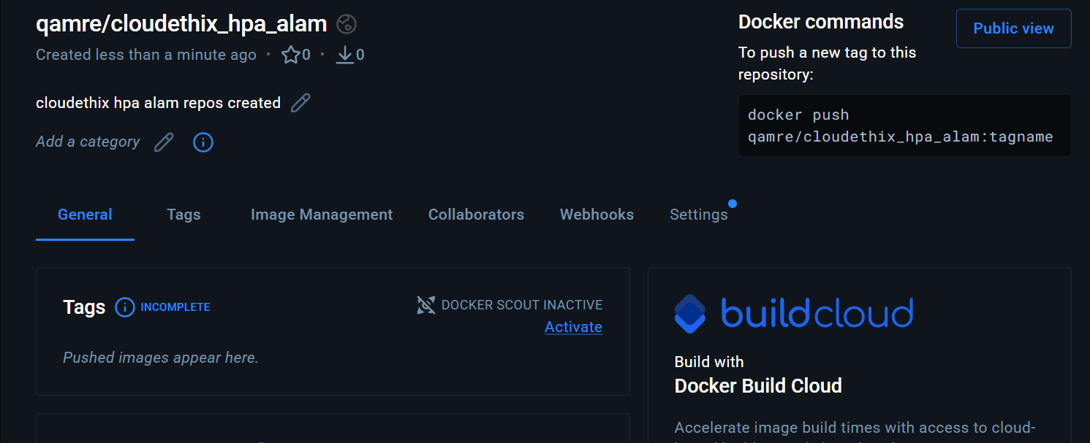

● Clone below repository on your system.
https://github.com/vivekamin/kubernetes-hpa-example.git

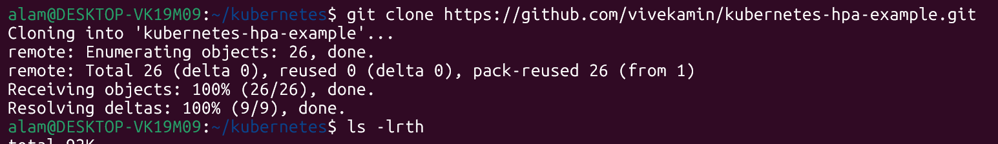

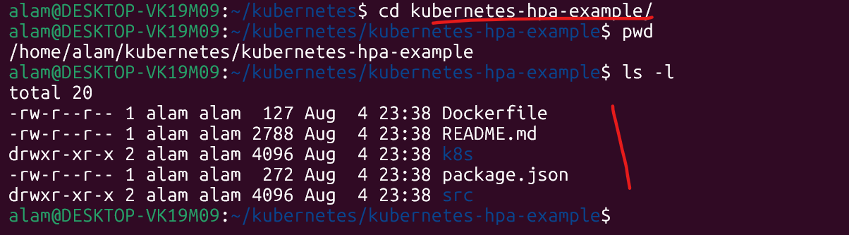

● Initialize a local repository & copy the code from above repo to your local repository in any of your working branch.
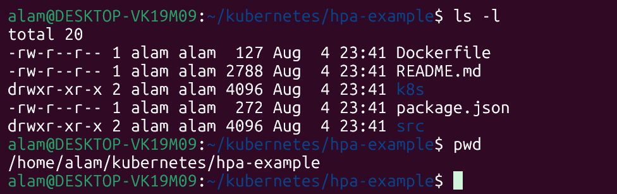

● Once code is copied , build a docker image from the docker file and add meaningful tags and push to the docker hub repository.

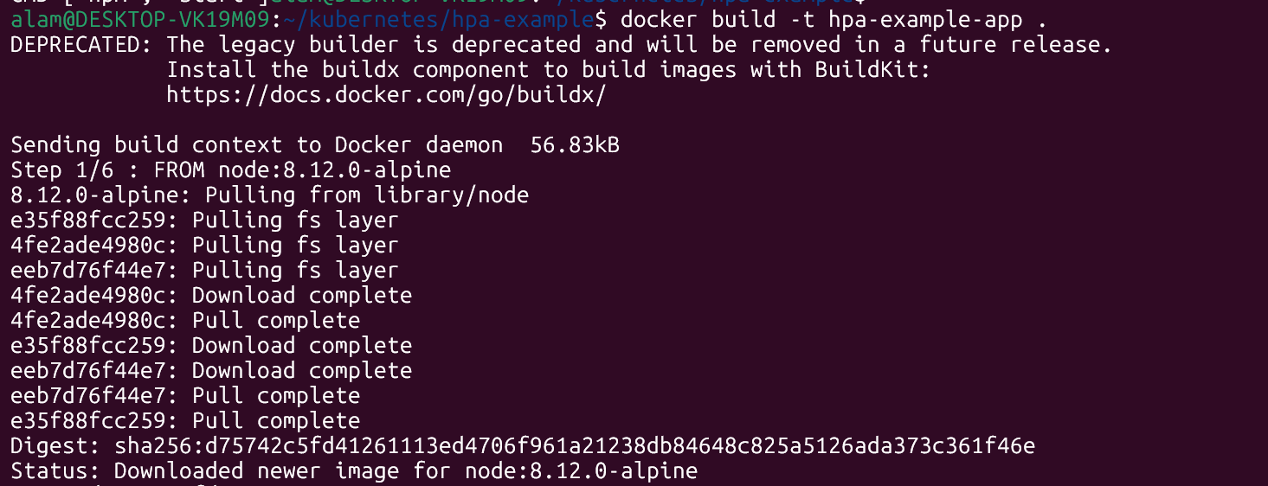

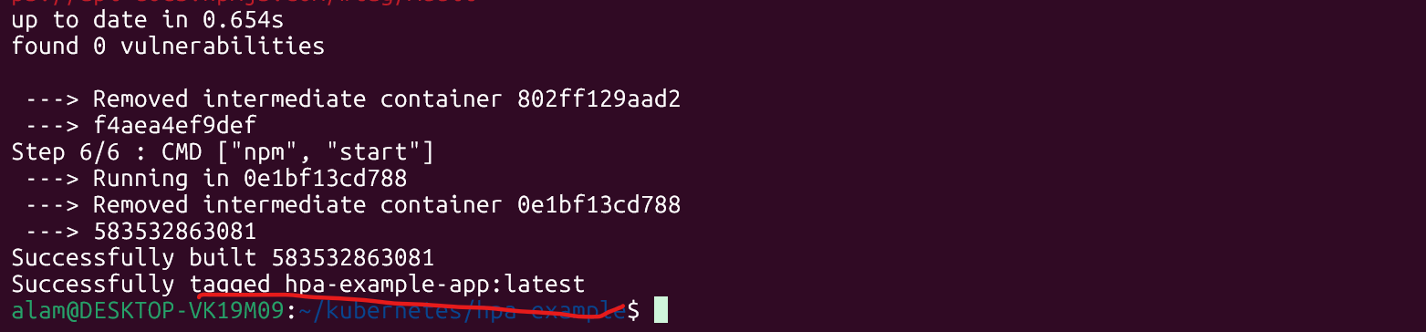

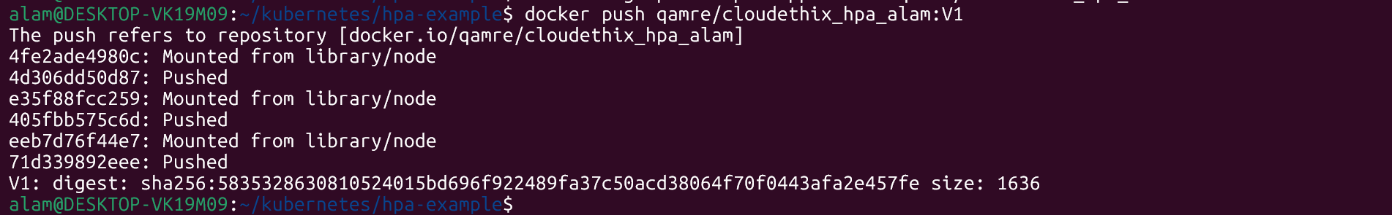

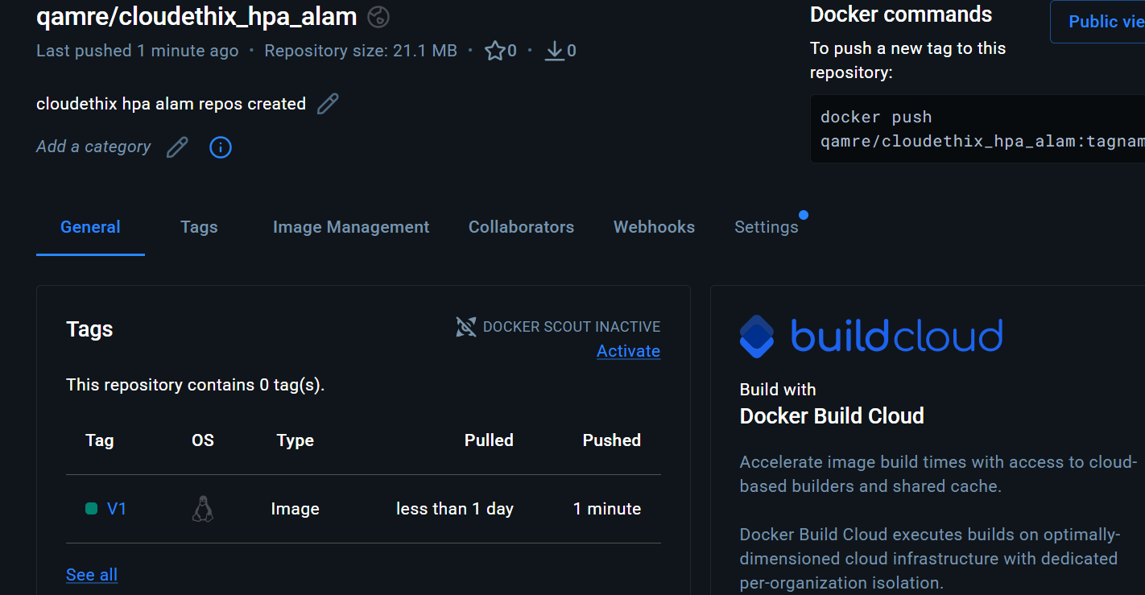

● Once the image is pushed, go to k8s directory and update deployment.yaml file with image name from your repo. And then create it.
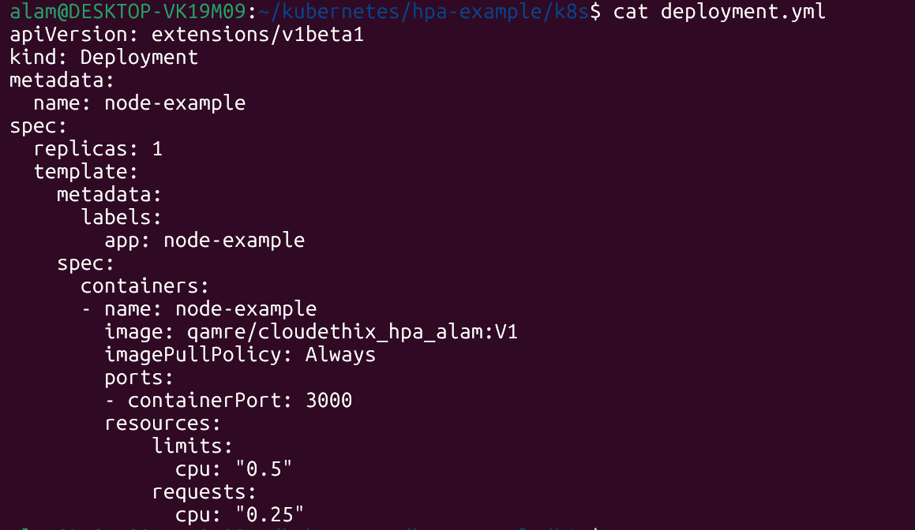

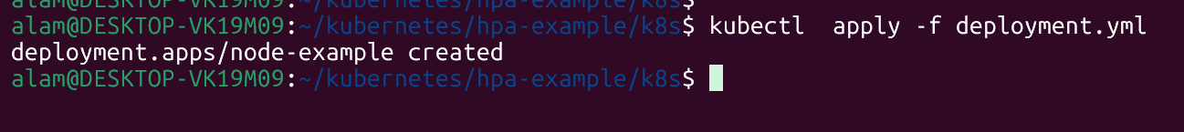

● Open service.yml and change the type to nodePort and apply the same.
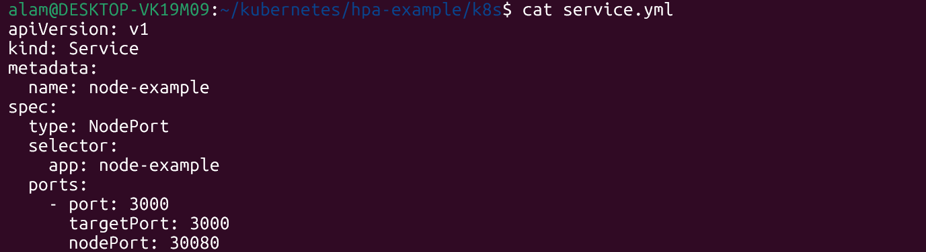

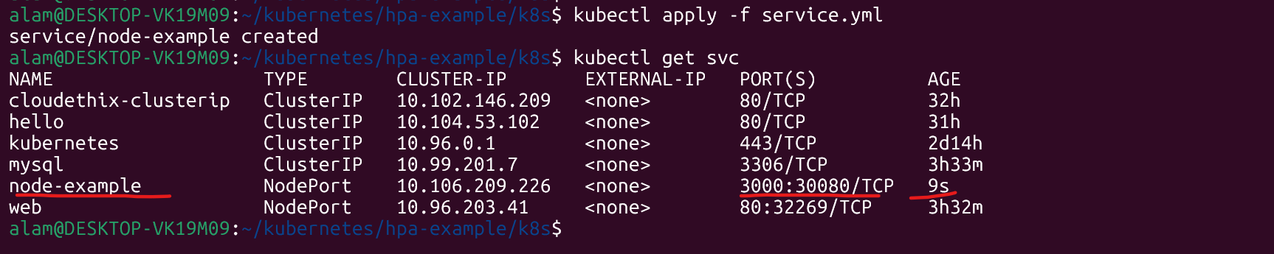

● Open the HPA.yaml file, notice it and then apply the same.
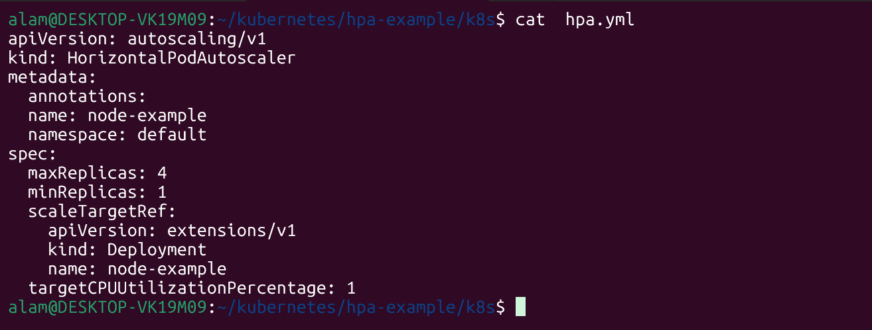

● Open the browser, and access the webpage.

● Now it's time to test the HPA working with the below command.

# kubectl run -i --tty load-generator --rm --image=busybox --restart=Never --
/bin/sh -c "while sleep 0.01; do wget -q -O- http://NODE_PORT_SERVICE_NAME;done"

● Check the HPA from kubectl command and also check if the deployment is scaling up.
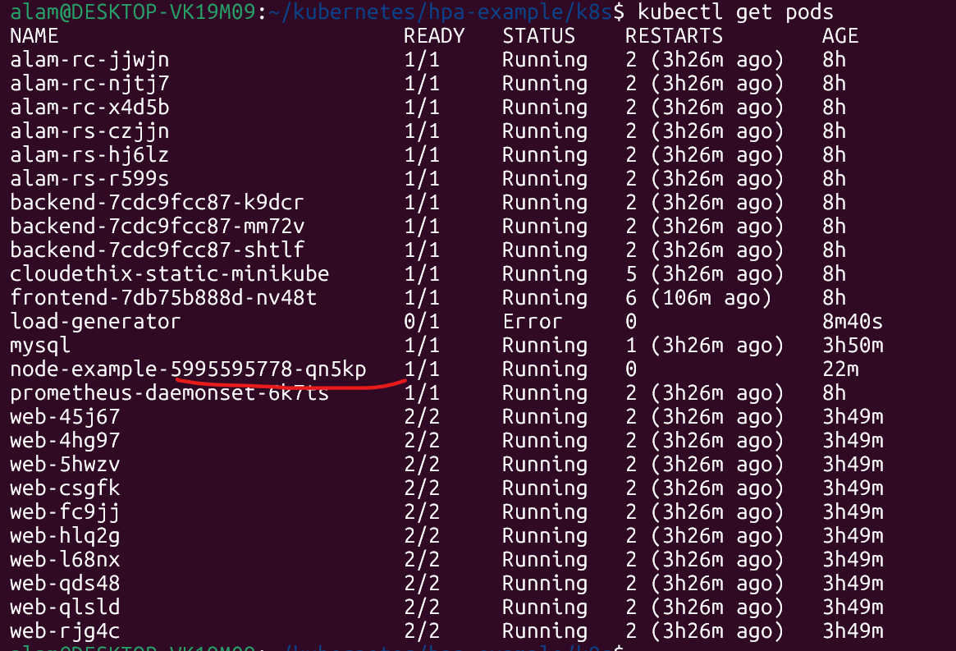

● Take the snap, prepare a well formatted doc and write your understanding.

Understanding of the Assignment
This assignment demonstrates how Kubernetes can automatically scale applications based on resource usage. The application is first containerized with Docker and stored in Docker Hub, making it available for deployment. Kubernetes then deploys the application and exposes it through a NodePort Service so it can be accessed externally. A Horizontal Pod Autoscaler monitors CPU utilization and dynamically adjusts the number of running Pods to meet demand. During load testing with a BusyBox container, HPA detects increased CPU usage and scales the Deployment up by creating additional Pods. When the load subsides, it scales the application back down, ensuring efficient use of cluster resources while maintaining application availability. This exercise highlights the integration of Docker, Kubernetes Deployments, Services, and HPA to achieve automated scaling and improved application resilience.

Que 7 →
● Create 1 Public Docker Hub registry named cloudethix_cronjob_yourname.
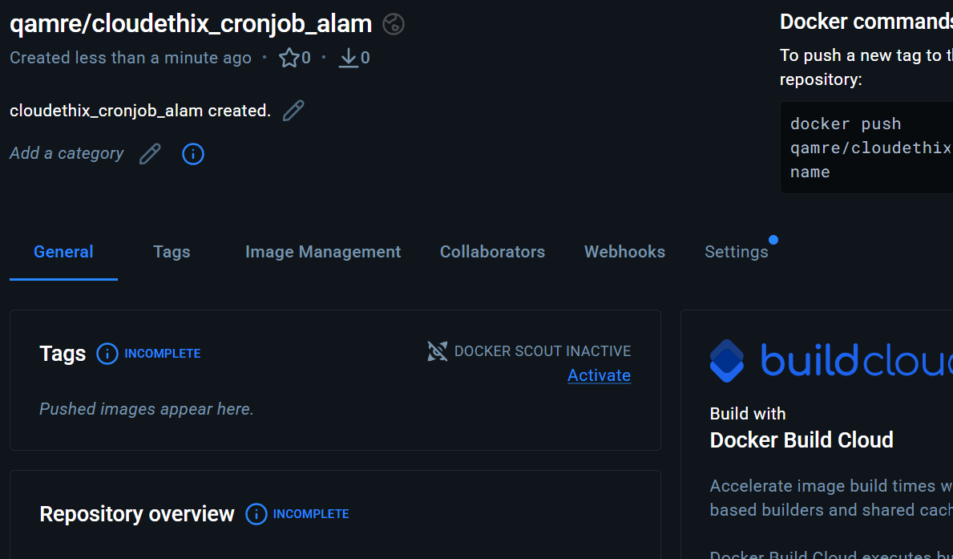

● Initialize a local repository & copy below code (three files) to your local repository in any of your working branch.

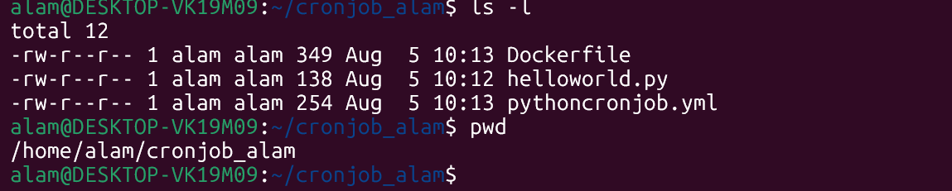

● Once code is copied, build the docker image from Dockerfile , add meaningful tags and then push the docker image to Docker hub registry.

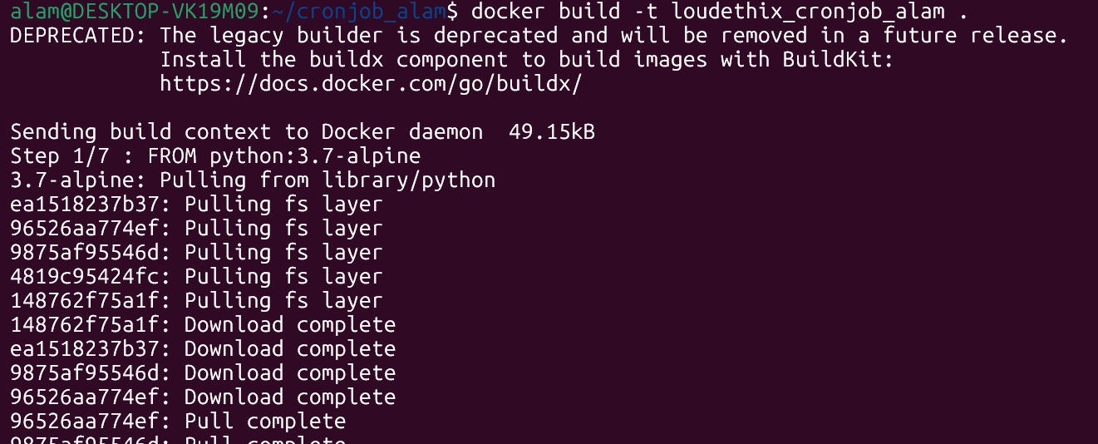

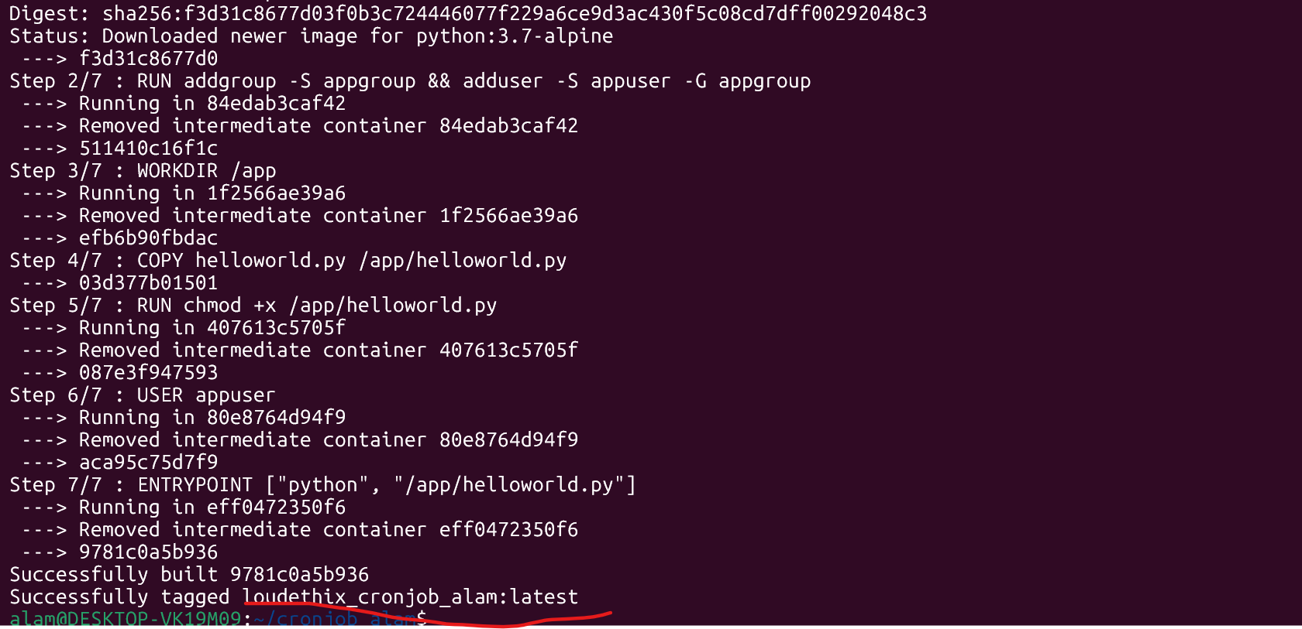

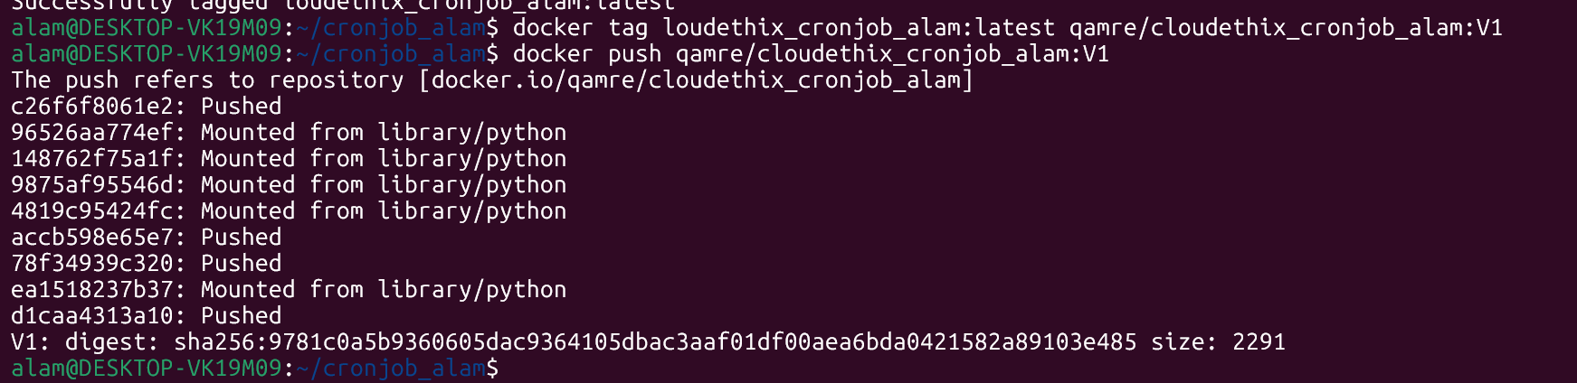

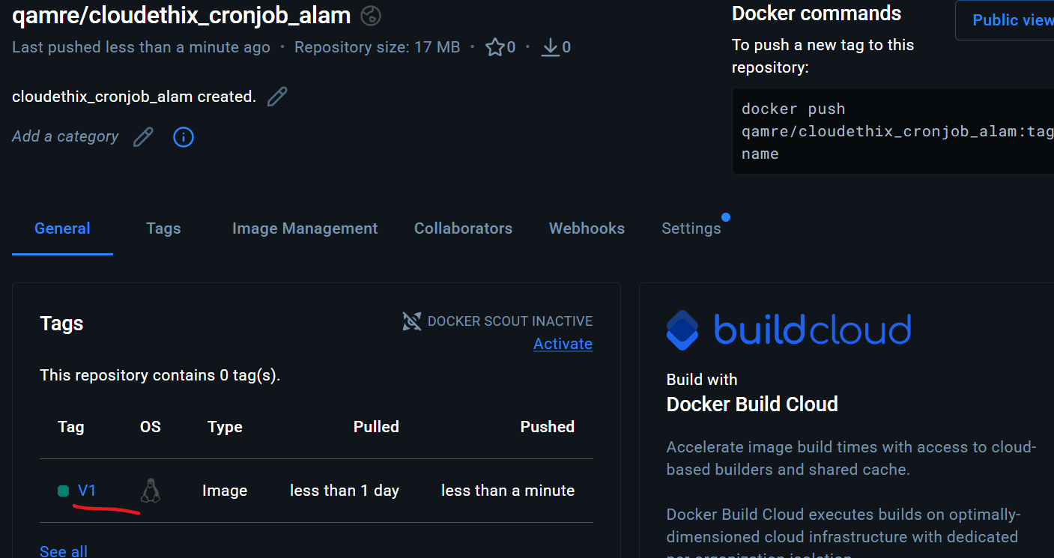

● Now update the pythoncronjob.yml file to change the image name that you have just pushed to docker hub registry.

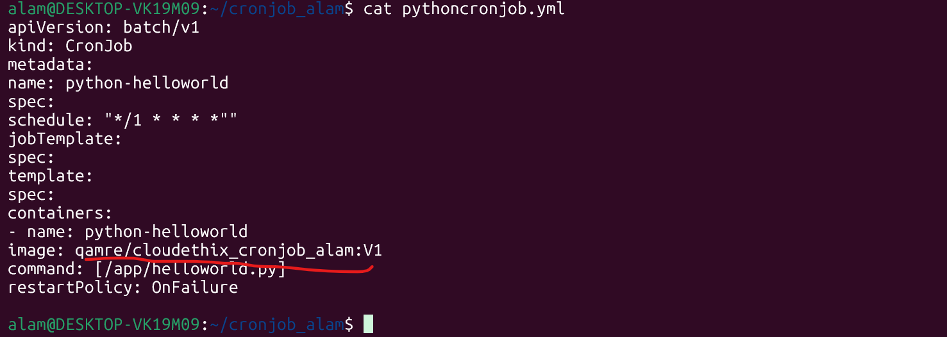

● Now create a cron job using pythoncronjob.yml file. Check with kubectl command if the cron job is created.

● Check the Job name which is created by cronjob from command line or lens.
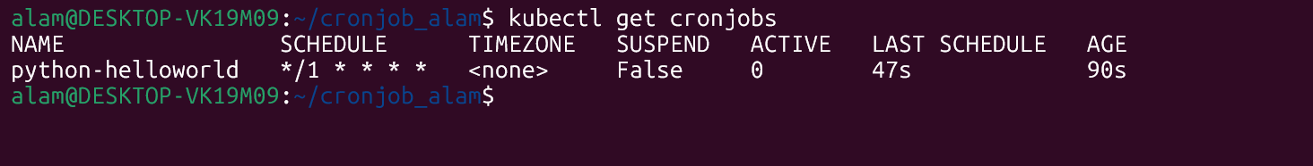

● Then check the pod logs which are created by the job and capture the output.

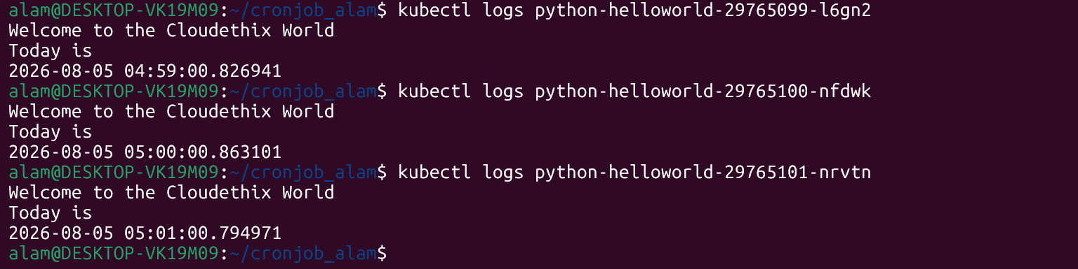

● Prepare well formatted documents and write your understanding.

# vim helloworld.py
#!/usr/local/bin/python3
import datetime
x = datetime.datetime.now()
print("Welcome to the Cloudethix World")
print("Today is")
print(x)
# vim Dockerfile
FROM python:3.7-alpine
#add user group and ass user to that group
RUN addgroup -S appgroup && adduser -S appuser -G appgroup
#creates work dir
WORKDIR /app
#copy python script to the container folder app
COPY helloworld.py /app/helloworld.py
RUN chmod +x /app/helloworld.py
#user is appuser
USER appuser
ENTRYPOINT ["python", "/app/helloworld.py"]
# vim pythoncronjob.yml
apiVersion: batch/v1
kind: CronJob
metadata:
name: python-helloworld
spec:
schedule: "*/1 * * * *""
jobTemplate:
spec:
template:
spec:
containers:
- name: python-helloworld
image: python-helloworld
command: [/app/helloworld.py]
restartPolicy: OnFailure

Understanding of the Assignment
This assignment demonstrates the complete workflow of packaging and deploying a Python application using Docker and Kubernetes. The Python script is containerized into a Docker image, which is stored in a public Docker Hub repository for easy distribution. A Kubernetes CronJob is then configured to run the container automatically at scheduled intervals. Finally, the deployment is verified by checking the CronJob, the Jobs it creates, the Pods started by those Jobs, and the application logs. This process illustrates key DevOps practices such as containerization, image management, orchestration, scheduling recurring workloads, and monitoring application execution within a Kubernetes environment.

